ERwin Methods

西南石油学院计算机科学系

目 录

1 Introduction 1
1.1 Welcome 1
1.2 Purpose for Methods Guide 1
1.3 Intended Audience & Use 1
1.4 Documentation Conventions 2
1.5 How to Use This Document 2
2 Information Systems, Databases, & Data Models 3
2.1 Relational Databases & the ER Model 3
2.2 The Relational Model 4
2.3 What Is Information Modeling? 7
3 Overview of the Language 8
3.1 Entities, Attributes & Relationships 8
3.2 Relationships & Foreign Key Attributes 12
4 Naming & Defining Entities & Attributes 17
4.1 What's in a Name? 17
4.2 Entity Definitions 19
4.3 Attribute Definitions 21
4.4 Domains 21
4.5 Datatyping & Rolenames 22
4.6 Definitions & Business Rules 24
4.7 Synonyms, Homonyms & Aliases 24
5 Some Model Details 25
5.1 More on Entities & Attributes 25
5.2 Relationship Types & Cardinality 32
5.3 Many-To-Many Relationships 36
5.4 Rolenames & Assertions 41
5.5 Existence & Identification Dependency 42
5.5.1 Relationship Descriptions & Insert, Replace, Delete (IRD) Rules 42
5.5.2 Delete Rules 43
5.5.3 Insert & Replace Rules 44
6 Normalization 45
6.1 Introduction 45
6.2 Common Design Problems 45
6.3 Summary of the Normal Forms 54
6.4 ERwin Support for Normalization 55
6.5 How Much Normalization Is Enough? 56
7 Information Modeling Methodologies 61
7.1 Information Modeling Objectives 61
7.2 ERwin Support for Modeling Methodologies 62
7.3 The Dbms Model for Relational Systems 65
7.4 Information Modeling Sessions 65
7.5 Summary 66

Introduction

Welcome
Welcome to information modeling with ERwin. If you have never seen a model before, the ERwin Methods Guide will help you understand what a model is, and what it is good for. If you already have some experience with data and information models, you know how useful they can be in understanding the requirements of your business. A model can help if you are designing new information systems or are maintaining and modifying existing ones.
Information modeling is not something that can be covered in a lot of detail in a short document like this one. But by the time you have read it, you will understand enough, even if you are just a beginner, to put ERwin's methods to work for you. This Document covers the methods of information modeling supported by ERwin. It does not cover the details of using ERwin. How to put the ERwin tools to work for you is covered in the ERwin User's Guide.

The information modeling method supported by ERwin has a mysterious acronym: "IDEF1X." The IDEF1X method was developed for the U.S. Air Force. It is now used by the Air Force, in various governmental agencies, in the aerospace and financial industry, and in a wide variety of major corporations where large scale, rigorous, enterprise-wide information modeling is essential.

Related Topics:

Purpose for Methods Guide

Purpose for Methods Guide
Overall, the ERwin Methods Guide has the following purposes:

- To provide a basic level of understanding of the information modeling method used by ERwin sufficient to do real database design.
- To introduce some of the descriptive power and richness of the IDEF1X modeling language supported by ERwin and to provide a foundation for future learning.
- To provide additional information which, along with the ERwin Tutorials, will allow you to better understand ERwin's modeling features.

Intended Audience & Use
The ERwin Methods Guide is designed to be used by:

- Novice data base designers --- as a primer on information modeling, and as a guide to using the ERwin Method.
- Experienced information modelers --- as a guide to IDEF1X data modeling and the ERwin Method.
- Experienced IDEF1X users --- as a guide to the features of IDEF1X supported by ERwin.

Documentation Conventions
The following conventions are used throughout the text:
Bold italics highlight new and important terms:

e.g., "An attribute is a property of an entity."

Non-bold italics bring words or phrases to the reader's attention:

e.g., "Entity names should always be singular."

ENTITY-NAMEs appear in CAPS:

e.g., "A CUSTOMER is described in the model as ..."

Plural ENTITYs are referred to by appending an 's' (ignoring spelling):

e.g., "A COMPANY operates in many CITYs" (rather than CITIES):

"Attribute-names" appear in quotes:

e.g., "A "customer-name" is recorded for each CUSTOMER."

<verb phrases> appear inside brackets:

e.g., "A CUSTOMER <borrows under> one or more MOVIE-RENTAL-AGREEMENTs."

How to Use This Document
If You Are Just Beginning:
We will assume that you know something about databases, so it is particularly important that you read the next Chapter. Together with the ERwin Tutorials, this document will provide you with all the background information you need to begin to create useful models with ERwin. Do not hesitate to begin applying ERwin right away to your application area. You will find that using ERwin will help teach you the method.
If You Have Experience With Another Modeling Language:
You are encouraged to review all of the ERwin Methods Guide, with emphasis on Chapters 4, 5 and 6.
If You Already Have Experience With IDEF1X:
You may find some of the background material of interest, and, you are encouraged to pay special attention to Chapters 5, 6 and 7. Although much of the presentation will be familiar, you will find some new ideas and interesting examples along the way.

Information Systems, Databases, & Data Models

Relational Databases & the ER Model
In order to compete, many enterprises are finding it advantageous to use information systems. Information systems generally provide the enterprise a service ?better management and readier access to information resources. In some cases, the information system is not only a service but a product that can be used to provide a strategic edge, as in the airline reservation or financial services industries. To realize the benefits of information systems, they must be developed in a timely and cost effective manner, they must meet real business needs and they must be modifiable and maintainable with minimum expense. Achieving these goals is a major challenge today.
One of the reasons information system development remains a challenge is that, as has been all too frequently observed, pro-gress in software development has not kept pace with progress in hardware development. The gap between software and hard-ware development is partly explained by the lack of standard methods and tools to boost the productivity of the people involved in the various phases of the software development process. In short, "The cobbler's children have no shoes."

Yet, over the last ten years, there have been significant advances in methods and tools for application development. There are methods and tools available that can significantly improve the chances of building a strategic information system that pays off. So it is not quite true, to say that the "cobbler's children have no shoes." There are shoes available. But it is often seen that the shoes are too expensive, fit poorly, or sometimes the children simply refuse to wear them.
The most important tool to emerge in the last ten years is the database management system or DBMS ?software that provides a reliable and convenient means of storing, retrieving and updating data. Given a choice between building an application using a DBMS or using no DBMS at all, few would disagree that using a DBMS is preferable.
Parallel to the development of the DBMS, new logical design methods for modeling data and designing databases have emerged. The most important and widely used method is called Entity-Relationship Modeling or "ER" modeling.

In the ER model, all data is viewed as stating facts about entities and relationships, i.e., connections or associations between entities. For example, an airline reservation information system has a database recording information about passenger flight reservations. The database represent facts about a FLIGHT entity, a PASSENGER entity and the relationship "carries" as in a "FLIGHT <carries> many PASSENGERs."

The Relational Model
The ER model provides a high-level "logical" view of your data. Beneath the ER model, there are three major types of data models: relational, hierarchical and network. The modern DBMS is usually based on one of these three models. In a DBMS based on the hierarchical model, data is stored using nested data structures. In a network DBMS, the hierarchical model is generalized and data is organized in a network of nodes and links. In a relational DBMS, all data is stored in a tabular format. The ER model is applicable to all three models but is closest to the relational model.
The tables in a relational DBMS consist of rows of data. Each row contains the same fields or columns. For example, suppose we have a simple database recording baseball teams and players. The TEAM table in our example has three columns and four rows of actual instances of the TEAM entity:

TEAM

Team-Name | Year | Team-City
Mets | 1989 | NYC
Yankees | 1989 | NYC
Dodgers | 1989 | LA
Red Sox | 1989 | Boston
Figure 2.1: TEAM table

The table name and the names of all of the columns of a table are said to constitute the table schema. Here is the schema for TEAM:
TEAM ( team-name, year, team-city)
In the relational model, all data values must be atomic ?you are not allowed to store a list of separate values in a cell. If we want to store information about the 1990 Mets we are not allowed to simply add "1990" to an existing row, (Mets, 1989 1990, NYC).
Instead we must add a separate row, (Mets, 1990, NYC), to the database.
The logical model of this database has two entities, PLAYER and TEAM, and a relationship, "has", between them. It is read as "A TEAM <has> many PLAYERs."
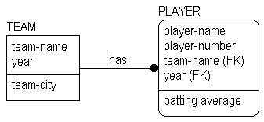
Figure 2.2: Model of database.

Each entity corresponds to a table. Here is an example of some of the rows in the PLAYER table:
PLAYER

Player-name | player-number | team-name | year | BA
D. Gooden | 16 | Mets | 1989 | .186
O. Herchiser | 55 | Dodgers | 1989 | .075
D. Mattingly | 23 | Yankees | 1989 | .269
Figure 2.3: PLAYER table.

The relationship "has" between the entities is represented by shared "team" and "year" values. The columns "team-name" and "year" are the keys of the TEAM entity (if we assume that a team can only be in one city in one year). To see what PLAYERs are on the 1989 Mets you have to look for these key values in the PLAYER table. We will say much more about keys and relationships in Chapters 3 through 7.

Related Topics:

Modeling Relationships
An Example Data Model

Modeling Relationships
All three data models represent information about entities in similar fashion ---for example, they all may use a table of records to store information about a particular FLIGHT. Where they differ the most is in the way in which they represent relationships.
Both the hierarchical and network model encode relationships with explicit physical pointer structures. The relational model encodes relationships implicitly using shared values. The ER method used by ERwin is relational in the sense that it uses shared keys to represent relationships. This is the hallmark of a relational system.
A network or hierarchical DBMS follows or "navigates" physical pointer structures to access information about a relationship. In contrast, a relational DBMS needs to use an operation called a join to find values in the related tables that match. By storing relationships implicitly, the relational model gains data independence. A relational DBMS allows physical data storage structures to change with minimum changes to application code. Data independence is a large part of the reason for the increasing move to relational DBMS.

Whenever there is a relationship between two entities, facts in one entity refer to, or are associated with, facts in another entity. Maintaining the relationships between entities is called referential integrity. Because relationships are stored implicitly in the relational model, it creates an extra burden of maintaining referential integrity. Today most of the burden rests with the application programmer. Increasingly, however relational DBMS are providing various forms of automated support for referential integrity such as triggers ?stored procedures attached to a table which fire whenever certain conditions obtain.
Whichever type of DBMS you use, drawing an ERwin model of your database has many benefits. The most obvious benefit is system documentation that can be used by database and application development staff to define system requirements and to communicate among themselves and to end-users. A second benefit is to provide a clear picture of referential integrity constraints. Maintaining referential integrity is essential in the relational model where relationships are encoded implicitly. A third benefit is the provision of a "logical" DBMS-independent picture of your database that can be used by automated tools to generate DBMS-specific information. Thus, ER
win generates DB2 table schemas from attribute level diagrams. The same diagram could be used to generate schemas for other DBMS as well.

An Example Data Model
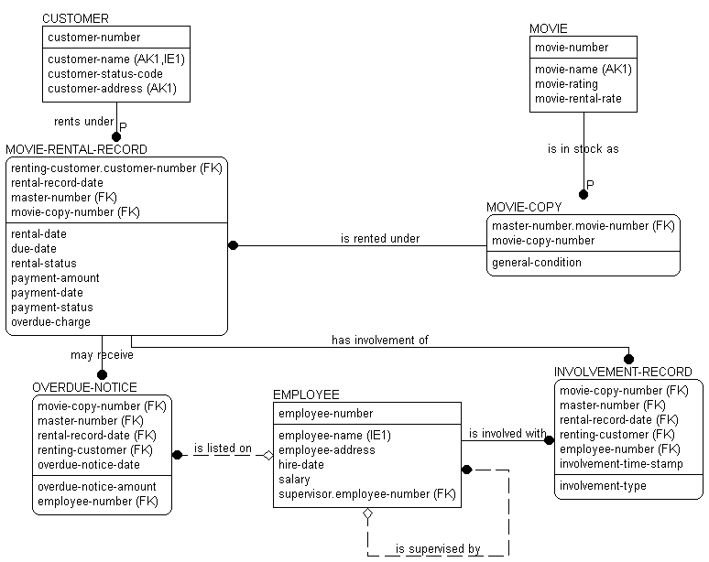
Figure 2.4: Example of a video store data model.

What Is Information Modeling?
An Information Model is a specification of the data structures and business rules needed to support a business area. It represents a set of business information requirements.
Information Modeling is the process of describing information structures and capturing business rules. It is an important part of the design of an information system. Figure 2.4, along with definitions of the objects presented on it, makes the following assertions:

- A MOVIE is in stock as one or more MOVIE-COPYs. In-formation recorded about a MOVIE includes its name, a rating, and rental rate. Each MOVIE-COPY has its general condition recorded, along with a projected future life.
- The store's CUSTOMERs rent the MOVIE-COPYs. A MOVIE-RENTAL-RECORD records the particulars of the rental of a MOVIE-COPY by a CUSTOMER. The same MOVIE-COPY may, over time, be rented to many CUSTOMERs.
- Each MOVIE-RENTAL-RECORD also records a due date for the movie, and a status indicating whether or not it is overdue. Depending on his or her previous relationship with the store, a CUSTOMER is assigned a credit status code which indicates whether the store should accept checks or credit cards for payment, or take only cash.
- The store's EMPLOYEEs are involved with many MOVIE-RENTAL-RECORDs, as specified by an involvement type. There must be at least one EMPLOYEE involved with each record. Since the same EMPLOYEE might be involved with the same rental record several times on the same day, involvements are further distinguished by a time stamp.

- A CUSTOMER's payment for a rental is recorded in the MOVIE-RENTAL-RECORD. An overdue charge is sometimes collected. OVERDUE-NOTICEs are sometimes needed to remind a CUSTOMER that a tape needs to be returned. An EMPLOYEE is sometimes listed on an OVERDUE-NOTICE.
- The store keeps salary and address information about each of its EMPLOYEEs. It sometimes needs to look up CUSTOMERs, EMPLOYEEs, and MOVIEs by their names, rather than by their "numbers."

This is a relatively small model, but it says a lot about the video rental store. From it, we not only can get an idea of what a database for the business should look like, but we also get a good picture of the business. There are several different types of graphical "objects" in this diagram. The entities, attributes and relationships, along with the other symbols describe our business rules. In the following Chapters and in the ERwin Tutorials you will learn more about what the different graphical objects mean and how to use ERwin to create your own information models.

Overview of the Language

Entities, Attributes & Relationships
In this Chapter, we will introduce the information modeling method used by ERwin and provide a brief overview of its richness and power for describing the information structures of your business. The examples used throughout the ERwin Methods Guide are deliberately chosen for simplicity and clarity of exposition. If you are new to information modeling, you should not be mislead by the apparent simplicity of the examples into thinking that the ERwin method will not work for your business. The method is tried and true and has been widely used for almost ten years in a wide variety of industries from aerospace to banking and finance.
One of the primary benefits of information modeling with ERwin is the ease with which you will be able to produce a diagram summarizing the results of your information modeling efforts.

Components of a Diagram
An ERwin diagram is made up of three main building blocks ?entities, attributes and relationships. If we view a diagram as a graphical language for expressing statements about your business, entities are the nouns, attributes are the adjectives or modifiers and relationships are the verbs. Building an information model with ER
win is simply a matter of finding the right collection of nouns, verbs and adjectives and putting them all together. In this Chapter, we will begin with an introduction to the basic concepts of entity and relationship. Chapters 4, 5 and 6 provide more detail on the more advanced features of the ERwin method.
Related Topics:
Definition of "Entity"

Basic Diagram Syntax for Entities & Attributes
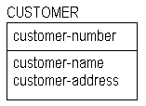
In an ERwin diagram, the CUSTOMER entity is represented by drawing a box with the name of the entity on top and all of the attributes of the entity inside the box. Entity names should always be singular ?CUSTOMER not CUSTOMERS, MOVIE not MOVIES, COUNTRY not COUNTRIES. By always using singular nouns, you gain the benefit of a consistent naming standard and facilitate "reading" the diagram as a set of declarative statements about entity instances.

Figure 3.2: Example entity.
The horizontal line in the entity diagram divides the attributes into two sets: keys and non-keys. The area above the line is called the key area, and the area below the line is called the data area. The key attribute of CUSTOMER is "customer-number," the non-key attributes are "customer-name" and "customer-address."
The set of attributes that identifies an entity is called its key. A key attribute is an attribute which, either by itself, or in combination with other key attributes, will form a unique identifier for an entity. Primary keys are placed above the line in the key area. As the name suggests, a non-key attribute is an attribute which has not been chosen as a key. These are placed in the data area.
In order to correctly use the CUSTOMER entity in our information model and later in our data base, we must be able to uniquely identify instances. How can we tell one customer from another? One method is to use the customer name as the key. Another method might be to assign a unique number to each instance of CUSTOMER. That is the choice that has been made in Figure 3.2.

A Maxim
Whenever someone proposes an entity for your model, one of the most important questions you need to ask is:

"How do we identify instances?"

Here is a maxim to help you remember this:

"No entity without identity!"

Entity instances in an ERwin model are always identified by key attributes.

Candidate Key Attributes
Choosing the key of an entity is an important step, and requires some serious consideration. There may be several attributes, or sets of attributes which could be used as primary keys. Attributes, or groups of attributes, which can be chosen as primary keys are called candidate key attributes. A candidate key must uniquely identify each instance of the entity. It follows that no part of the key may be NULL, i.e., "empty" or "missing." In general, there is a certain amount of discretion involved in the selection of primary keys. But you have to be careful in choosing them. Just think what might happen if, for instance, the government identified each taxpayer by his or her name, and you happened to be John Smith. You could spend your entire life trying to straighten out whose taxes and benefits were whose.

Related Topics:

Example Key Selection
Choosing a Primary Key
Alternate Key Attributes

Relationship Defined
Relationships represent connections, links or associations between entities. They are the "verbs" of a diagram showing how entities relate to each other. Here are some examples:

A TEAM <has> many PLAYERs.
A PLANE-FLIGHT <transports> many PASSENGERs.
A DOUBLES-TENNIS-MATCH <requires> exactly 4 PLAYERs.
A HOUSE <is owned by> one or more OWNERs.
A COMPUTER <is built from> many DISK-DRIVEs.
A SALESPERSON <sells> many PRODUCTs.

In all of these cases, the relationships are chosen so that the connection between the two entities is what is known as 1-to-many. This means that one (and only one instance) of the first entity is related or connected to many instances of the second entity. The entity on the "1-end" is called the parent entity, the entity on the "many" or dotted end is called the child entity.

Related Topics:

How many is "many"?
Basic Diagram Syntax for Relationships

Reading a Model
If you choose your verb phrases correctly, you should be able to "read" a relationship from the parent to the child using an "active" verb phrase. The previous diagram would be read as

A PLANE-FLIGHT <transports> many PASSENGERs.

The next diagram below is read as:

A CUSTOMER <borrows under> many MOVIE-RENTAL-RECORDs.
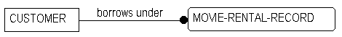
Figure 3.7.

A MOVIE <is available as> many MOVIE-COPYs.
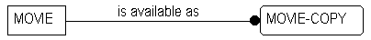
Figure 3.8.

A PERSON <may have> many HOBBYs.
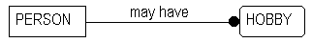
Figure 3.9.

The next example involves associative entities. They tend to be more difficult to "read," so we will come back to this example in Chapter 5.2 (Fig. 5.14.).

A PERSON <may use> many ADDRESS-USAGEs.
An ADDRESS is <used by> many ADDRESS-USAGEs.
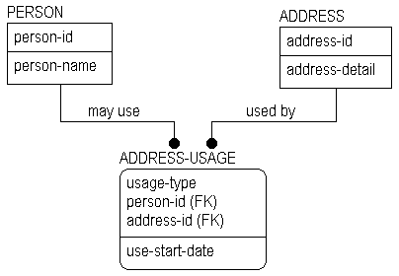
Figure 3.10. Associative entity example.

Verb phrases can also be read from the perspective of a child entity, as "passive" verb phrases. For example:
Figure 3.7: A MOVIE-RENTAL-AGREEMENT <records borrowing by> a CUSTOMER.
Figure 3.8: A MOVIE-COPY <records the availability of> a MOVIE.
Figure 3.9: A HOBBY <may be had by> a PERSON.
An information model exposes many of the business rules that describe the area being modeled. Verb phrases provide a brief summary of the business rules embodied by relationships. Although they do not precisely describe the rules, they allow the person who is looking at the model to get an initial sense of how the entities are connected. It is a good practice to make sure that reading the model gives valid statements. Reading your model back to the business is one of the primary methods of verifying that it has correctly captured the business rules.

Generalization Hierarchies and Inheritance
A generalization or inheritance hierarchy, also referred to as a sub-type, or (sub)category hierarchy, is a way to group a set of entities which share common characteristics. For example, we might find during a modeling effort, that several different types of ACCOUNTs exist in a bank, such as checking, savings and loan accounts. A generalization entity (or generic parent ) called ACCOUNT might be formed, to represent the information which is common across the three types of accounts, yielding a structure like that shown in the Figure 3.11 below.
There are various terminologies people use to designate the entities in a generalization hierarchy. IDEF1X uses the term category to refer to the "subtype" or child of the generic parent. Others use the term subcategory for the child entity. We will follow IDEF1X in this document so by "category" we will mean sub-type or subcategory.

Related Topics:

Category discriminators

Relationships & Foreign Key Attributes
In the previous Chapter on the Relational Model (2.2), we saw that one of the main differences between the relational model and the hierarchical or network models is the representation of relationships. The hierarchical and network models represent relationships by pointer data structures at the physical level. In contrast, the relational model captures relationships with shared keys at the logical level.
The IDEF1X modeling language used by ERwin also represents relationships by shared keys. Although IDEF1X certainly can be, and is, used to model information that is stored in non-relational Data Base Management Systems, in its treatment of keys, IDEF1X is relational.
Whenever entities in a ERwin diagram are connected by a relationship, the relationship contributes a key (or set of keys) to the child entity. Foreign key attributes are defined as primary key attributes of a parent entity contributed to a child entity across a relationship. The contributed keys are said to migrate from parent to child. Foreign key attributes are de-signated in the model by an (FK) following the attribute name. Notice the (FK) next to "parent-key" in Figure 3.12 below.

Related Topics:
Identifying and Non-identifying Relationships
Independent Entities
Dependent Entities
Rolenames

Identifying and Non-identifying Relationships
In an identifying relationship, foreign keys migrate to the key area (above the line).
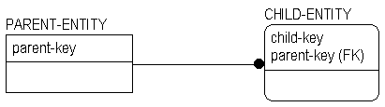
Figure 3.12: Identifying relationship.

The relationship is called identifying because the keys of the parent form part of the identity of the child: the child is dependent on the parent for its identity. Identifying relationships are indicated by a solid line connecting the entities, with a dot on the end. All of the relationships we have seen so far have been identifying.
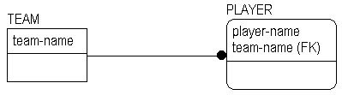
Figure 3.13: Identifying relationship.

In this example, PLAYERs are identified by both their "team name" and their "player name." This is necessary because over time, the same player may play for different teams. And the business (managing baseball statistics let's say) needs to distinguish team members over time.
An identifying relationship carries with it a business rule which says that the business has made an intentional choice to identify the child entity by using the identifier of the parent entity. In our example of MOVIEs and MOVIE-COPYs in 3.8, we could have chosen to identify the copy by its own unique number. Instead, we decided to use the identifier of the MOVIE and add a second part (copy-number) to tell one copy from another.
Non-identifying relationships (dashed lines) also connect a parent entity to a child entity. A non-empty subset of the foreign keys migrated by non-identifying relationships are placed in the data area (below the line).
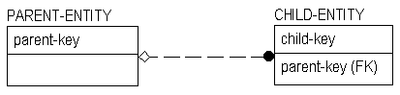
Figure 3.14: Non-identifying relationship.

Since some (or all) of the migrated keys in a non-identifying relationship are not part of the primary key of the child, the child is not identified by the parent. As we shall see in Chapters 5 and 6, this difference is very important when we need to maintain the integrity of the relationship between parent and child under the operations of insertion, deletion and update. This is known as the problem of referential integrity.
In the PASSENGER-SEAT example, the airline business has chosen to identify an instance of SEAT-RESERVATION by "seat number."
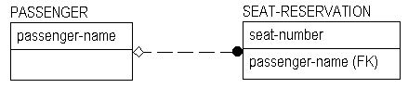
Figure 3.15: PASSENGER-SEAT example.

Because occupants of the same seat change from one flight to the next, the current PASSENGER is not part of the key. This model is still inadequate, however, as "seat number" alone is not sufficient to identify the current PASSENGER whose seat is reserved. In the model below, we have extended the key of SEAT-RESERVATION to include the "flight-number" by asserting an identifying relationship between FLIGHT and SEAT-RESERVATION. (See Chapter 5 for more on non-identifying relationships.)
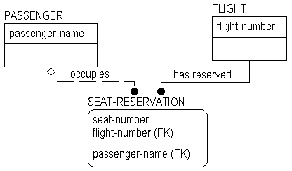
Figure 3.16: SEAT-RESERVATION example.

Independent Entities
Entities are designated as either independent entities, or dependent entities, depending on how they acquire their keys.
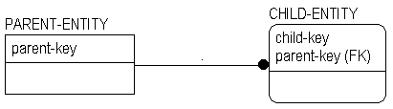
Figure 3.17: Independent entity and dependent entity.

Independent entities are represented by square corner boxes. You may hear them referred to as "square boxes" (a bit of a misnomer ?they are usually rectangles). An independent entity does not depend on any other entity in a model for its identification. In our earlier examples, (Figures 2.4 and 3.7), each CUSTOMER was identified by a unique "customer-number." On the other hand, our rental store had many copies of the same MOVIE. Here the business had two choices ?either to individually identify each MOVIE-COPY with its own unique "movie-copy-number" (which would make it an independent entity) or to identify the copy by a combination of "movie-number" and "copy-number" (the chosen alternative). Because "movie-number" is an identifier of the MOVIE (not the copy), MOVIE-COPY is said to be dependent on MOVIE for its identification.

Dependent Entities
Dependent entities are represented by boxes with rounded corners. You may hear them referred to as "rounded boxes," "roundy boxes," "puffy boxes" and so on. Dependent entities depend both for their existence and for their identification on some other entity or entities in the model.
Relationships usually result in dependencies between parent and child. In existence dependency, the dependent entity cannot exist unless its parent does. In identification dependency, the dependent entity cannot be identified without using the key of the parent. Identifying relationships always result in both existence and identification dependency.
To illustrate identification dependence, a MOVIE-COPY cannot be identified without a "movie-number" which identifies some MOVIE (identification dependency), and a PLAYER cannot be identified without a "team name."
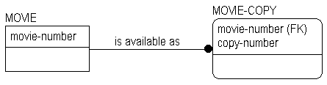
Figure 3.18: Movie example.
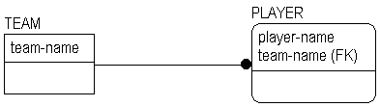
Figure 3.19: Team example repeated from above.

A MOVIE-COPY cannot exist if there is no MOVIE, and a PLAYER cannot exist if there is no TEAM to which he or she belongs. Non-identifying relationships do not result in any identification dependency (as the migrated keys fall below the line). However, many of them result in existence dependency as shown in greater detail in Chapter 5.

Rolenames
A rolename is a new name for a foreign key attribute which defines the role that the attribute plays within the entity.A rolename declares a new attribute, whose name is intended to describe the business statement embodied by the relationship which contributes the foreign key.
Here is a simple example:
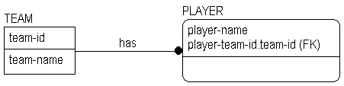
Figure 3.20: Rolename example.

The key attribute of PLAYER, "player-team-id.team-id," shows us the syntax for defining and displaying a rolename. The first half (before the period) is the rolename. The second half is the original name of the foreign key, sometimes called the base-name.

role-name.base-name

Rolenames migrate across relationships just like any other attributes. For example, suppose that we extend the example to show which PLAYERs have scored in various games throughout the season.
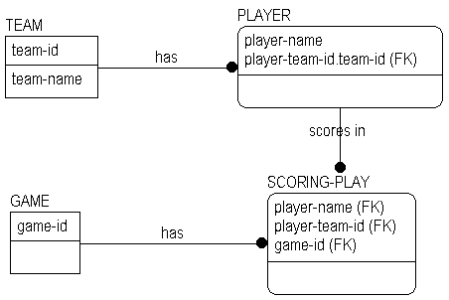
Figure 3.21: Diagram with rolenames migrated.

Here, we could have chosen to create new rolenames for primary keys of SCORING-PLAY, but chose not to do so. Figure 3.22 shows the result if our decision is to provide new rolenames.
The "chain" of rolenames reaches from SCORING-PLAY all the way back to TEAM. Notice, however, that the display in each entity reaches back across only one "link" of that chain.
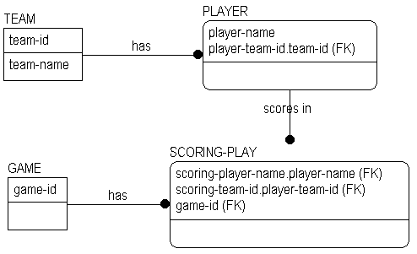
Figure 3.22: Diagram with new rolenames.

Naming & Defining Entities & Attributes

What's in a Name?
What's in a name? Well, when it comes to entities and attributes, just about everything.
It is extremely important in information modeling, and in systems development in general, to choose clear and well thought out names for objects. Naming and defining entities and attributes is so important that we will devote an entire chapter to it.

Related Topics:

Singular Names
Naming for Clarity

Singular Names
Entity names are always singular. We have made a point to do this throughout all the examples. Doing so facilitates reading the model with declarative statements such as "A FLIGHT <transports> zero or more PASSENGERs" and "A PASSENGER <is transported by> one FLIGHT." When we name the set of instances represented by the entity we are giving a name to an instance. Each instance of the PASSENGER entity is an individual passenger, not a set of "passengers."
Attribute names are singular too, e.g., "person-name," "employee-SSN," "employee-bonus-amount." The reason for naming attributes in the singular is partly a matter of a consistent naming policy and partly to avoid certain kinds of normalization errors. You might have an intuitive sense that something was amiss if you saw an attribute name like "person-hobbies." How many? How do we tell one from another? How would we represent them in a sample instance table? And so on. Your intuition would be correct ?there is something wrong. We will return to this in our discussion of normalization in a later chapter.

Naming for Clarity
It is important to choose a name that will clearly communicate a sense of what the entity or attribute represents. For example, we get a clear sense that there is some difference among things called PERSON, CUSTOMER, and EMPLOYEE. Although they all represent some individual (well, maybe not CUSTOMER, if it's a company of some sort), they have distinct characteristics or qualities.
Choose your names carefully, and be wary of calling two different things the same if they are not. For example, if you are dealing with a business area which insists on calling its customers "consumers," don't force or insist on the name. You may have discovered an alias, another name for the same thing, or you may have a new "thing" that is distinct from, although similar to, another "thing." (In this case, perhaps you have a category of CUSTOMER which may participate in relationships which are not available for other categories of CUSTOMER).

You may sometimes find that it is difficult to give an entity or attribute a name without first giving it a definition. As a general principle, providing a good definition for an entity or attribute is as important as providing a good name. The ability to find meaningful names comes with experience and a fundamental understanding of what the model represents.
Naming associative entities can present significant challenges for finding meaningful names. Let's look at an example.
In Figure 3.10 we gave the association or intersection between PERSON and ADDRESS the name ADDRESS-USAGE. How did we choose this name?
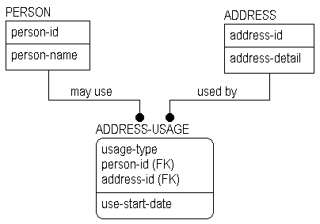
Figure 3.10: From previous chapter.

Our first inclination might be to call this entity PERSON-ADDRESS. Most people tend to do something like this at first. The problem is that the entity represents neither a PERSON nor an ADDRESS, and the name PERSON-ADDRESS would lead us to believe that this entity is some sort of PERSON or some sort of ADDRESS.
What the entity really represents is the "use" of an ADDRESS by a PERSON, and any information we want to keep about that "use." ADDRESS-USAGE captures most of this but it is a little too short. PERSON-ADDRESS-USAGE would have told us more.
Remember that an information model is a description of a business. Choose meaningful business names wherever that is possible. But suppose there is no business name for an entity like this (the business probably doesn't think of things like "person address usages")?
In such cases, it can be best to simply give the entity a name that fits its purpose in the model, and be done with it. There is little more futile than trying, with someone who doesn't understand or care why the entity is there, or has conceded its existence because it is "part of the methodology," to try to find a meaningful name. But if this is an entity that directly corresponds to a business "thing," it should have a business "name."

Entity Definitions
All entities should be defined, although ERwin does not force the use of such definitions (it is perfectly happy to draw the diagrams without the accompanying definitions). Writing a good definition is more difficult than it might initially seem. Everyone knows what a PERSON is, right? Just try writing a definition of a PERSON which will hold up to scrutiny. Attorneys have been having a good time with that one for years.
Most organizations and individuals develop their own conventions or standards for definitions. In practice you will find that long definitions tend to take on a structure which can help the reader to understand the "thing" being defined. Some of these definitions can go on for several pages (PERSON, for example). You may want to adopt the following "standards" for the structure of a definition as a starting point, even though IDEF1X does not provide standards for definitions.

Related Topics:

Descriptions
Business Examples

Descriptions
The description should be a clear and concise statement that will tell us whether an object is or is not the thing we are trying to define. Often such descriptions can be fairly short. Be careful, however, that the description is not too general, or uses terms which themselves have not been defined. Here are a couple of examples, one of good quality, and one which is questionable.

"A COMMODITY is something which has a value which can be determined in an exchange."

This is not too bad. We might wonder what an "exchange" is, and we might need to understand a bit more what "value" is, but we can generally know that something is a COMMODITY if someone is, or would be, willing to trade something for it. If someone is willing to give us three peanuts and a stick of gum for a marble, then we know that a marble is a COMMODITY. And so are peanuts and sticks of gum.

"A CUSTOMER is someone who buys something from our company."

This is not too good. First, can a "someone" be another company? Second, does a CUSTOMER have to have already have bought something from us to be considered one? What about "potential" for sales in the future, even if there are none now? And so on.

Business Examples
It is a good idea to provide typical business examples of the thing being defined, and to avoid defining things by example. Good examples can go a long way to help the reader understand a definition. Although they are a bit "unprofessional," comments about peanuts and marbles can help a reader to understand the concept of a COMMODITY. The definition said that it had "value." The example can help to show that value is not always "money."
General comments (perhaps structured in some way) about things like who is responsible for the definition, what state it is in, when it was last changed, or what its source was are very helpful. It is also helpful to record, as part of a definition, comments which explain how something which is similar to the entity being defined is not exactly the same. For instance, a CUSTOMER might be distinguished from a PROSPECT. They may at first look like the same thing, but if the business says so, they are indeed different things.

Constructing a definition for an associative entity can be a bit difficult at first. Look again at Figure 3.10, and define ADDRESS-USAGE. Remember that an associative entity records "intersection" data ?it pairs the keys of the entities being "associated." You may see something like the following as a first try.

"An ADDRESS used by a PERSON."

No. The only problem is, this is not an ADDRESS! How about:

"Information about an ADDRESS used by a PERSON."

Closer, but still not correct. Information about an ADDRESS is recorded as attributes of ADDRESS. How about:

"Information about the use of an ADDRESS by a PERSON"

Yes. Remember that associative entities often represent many-to-many relationships which have been broken down into a pair of one-to-many relationships with the associative entity in the middle.

Attribute Definitions
As with entities, it is important to define all attributes clearly. The same rules apply ?by comparing a thing to a definition, we should be able to tell if it fits. Again, this is more difficult than it may first sound.
For example, what is a good definition for "person-name"? We could always try "A title by which a person is known", with a distinction between a PERSON's name and his or her nickname. But, still, what is a name?
Is it a title by which the PERSON is commonly addressed? Or what is listed on a birth certificate? Or with the government for tax and other purposes? Or what? Or are all of these "uses" of some sort of "name" by the PERSON (or something else)?
The attorneys have a field day here too.
Beware of things like "account-open-date" defined as, "The date on which the ACCOUNT was opened." Now what is it that we mean by "opened"?

Attribute definitions generally should have the same basic structure as entity definitions (i.e., description, examples, comments, etc.). Description and comments certainly apply. Business examples are useful sometimes. Business examples lead us to the world of domains.

Domains
A domain can be thought of as a set of values that an attribute is allowed to take. These values have meanings in both an abstract and a business sense. For example, "person-name," if it is defined as the preferred form of address chosen by the PERSON, has as a domain the set of all character strings. People could choose to call themselves by phrases, numbers, descriptions, or other such things, as well as more conventional "names" like Ben, or Tom.
In more formal descriptions of IDEF1X, and relational modeling in general, an attribute is said to be defined over a domain. Definitions of attributes such as codes, identifiers, amounts, etc., often do not lend themselves to good business examples. Including a description of the attribute's domain is usually a good idea. When defining a domain it is good practice to go beyond listing the "values" that an attribute can take. Suppose we define the attribute "customer-status" as follows:

Customer-status: A code which describes the relationship between the CUSTOMER and our business.
The following domain specification would not be too helpful:
Domain: A, P, F, N

This would be much better!

Domain | Meaning
A: Active | The CUSTOMER is currently involved in a purchasing relationship with our company.
P: Prospect | Someone with which we are interested in cultivating a relationship, but with whom we have no current purchasing relationship.
F: Former | The CUSTOMER relationship has lapsed ---i.e., there has been no sale in the past 24 months.
N: Never (do business with this guy) | The company has decided (for reasons we might go on to describe) that no business will be done with this CUSTOMER.
Attribute domains have definitions, and these definitions are an important part of the definition of the attribute.

Datatyping & Rolenames
It is often the case that several attributes in a model will be defined over the same domain. In other words, they will have the same allowed values, but not the same definitions. This is generally the case in situations where foreign keys are contributed to an entity by a relationship. IDEF1X provides rolenames to allow different occurrences of the same underlying attribute to play different roles. (See Chapter 3.)
Consider the example in Figure 4.1. Here we see a FOREIGN-EXCHANGE-TRADE with two relationships to CURRENCY.
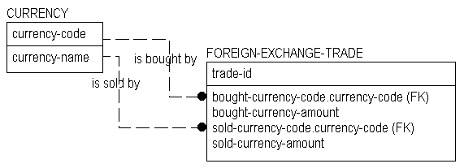
Figure 4.1: Currency Example.

The key of CURRENCY is "currency-code," (the identifier of a valid CURRENCY that we are interested in tracking). We see from the relationships that one CURRENCY is "bought by," and one is "sold by" a FOREIGN-EXCHANGE-TRADE.
We see also that the identifier of the CURRENCY (the "currency-code") is used to identify each of the two CURRENCYs. The identifier of the one which is bought is called "bought-currency-code" and the identifier of the one which is sold is called "sold-currency-code." These are rolenames. We can think of "bought-currency-code" and "sold-currency-code" as datatypes of "currency-code." But they are not the same thing as "currency-code."
It would be somewhat silly to trade a CURRENCY for the same CURRENCY at the same time and exchange rate. Thus, for a given transaction (instance of FOREIGN-EXCHANGE-TRADE) "bought-currency-code" and "sold-currency-code" must be different. By giving different definitions to the two rolenames, we can capture the difference between the two currency codes.

Attribute/Rolename | Attribute Definition
currency-code | The unique identifier of a CURRENCY.
bought-currency-code | The identifier ("currency-code") of the CURRENCY bought by (purchased by) the FOREIGN-EXCHANGE-TRADE.
sold-currency-code | The identifier ("currency-code") of the CURRENCY sold by the FOREIGN-EXCHANGE-TRADE.
The definitions and domains of the bought and sold codes are based on "currency-code." "Currency-code" is called a base attribute.
Definition References & Circularity. If you open up a diction-ary, like Webster's, you will often find a situation like this:

TERM-1 Definition includes reference to, or is based on TERM-2.
TERM-2 Definition includes reference to, or is based on TERM-3.
TERM-3 Definition includes reference to, or is based on TERM-1.

The individual definitions look good, but when viewed together are found to be "circular." Without some care, this can happen with entity and attribute definitions. For example:

CUSTOMER: Someone who buys one or more of our PRODUCTs.
PRODUCT: Something we offer for sale to CUSTOMERs.

Oops! With care, a lot of care, it is possible to avoid these situations. Doing it for this example is an exercise left to the reader.
It is often convenient to make use of common business terms when defining an entity or attribute. For example:

"A CURRENCY-SWAP is a complex agreement between two PARTYs in which they agree to exchange cash flows in two different CURRENCYs over a period of time. Exchanges can be fixed over the term of the swap, or may float. Swaps are often used to hedge currency and interest rate risks."

You will have noticed a style in which defined terms within a definition are highlighted. Using a style like this makes it unnecessary to define terms each time they are used, since people can look them up whenever needed.
If it will be convenient to use terms which are not the names of entities or attributes, (e.g., common business terms), it is a good idea to provide base definitions of them, and refer to these definitions as would be done for references to entity or attribute definitions. A glossary of commonly used terms, separate from the model, can be used. Such common business terms are highlighted with bold-italics, as in the above passage.
It may seem that a strategy like this will lead to a lot of flipping back and forth among definitions, and it will. The alternative, however, is to completely define each term every time it is used. If these "internal definitions" appear in many places, they will have to be maintained in many places, and the probability that a change will be applied to all of them at the same time will be very small.

Developing a glossary of common business terms can serve several purposes. It can become the "base" for use in modeling definitions, and it can, all by itself, be of significant value to the business in helping people to communicate.

Definitions & Business Rules
Business rules have been mentioned earlier as an integral part of the information model. More of these business rules can be found in entity, attribute, and domain definitions.
The CURRENCY entity in Figure 4.1 could be defined either as the set of all valid currencies recognized anywhere in the world, or could be defined as the subset of these which our company has decided to use in its day to day business operations. This is a subtle, but important distinction.
In the latter case, there is a business rule involved, a "policy statement" if you will.
This rule manifests itself in the domain of "currency-code." It restricts the general domain of all valid "currency-code"s to the subset of only those which we will use. Maintenance of the business rule becomes a task of maintaining the CURRENCY table. To permit or prohibit trading of CURRENCYs, instances are created or deleted.

The "bought-currency-code" and "sold-currency-code" attributes' domains are similarly restricted. One of them is restricted even further by a constraint that says that it is dependent on the value of a certain other attribute in its actual use. It is important to understand the basic principles involved here. Domains need to be addressed in the definitions of attributes (as they are not directly specified or given a standard treatment by the IDEF1X language).

Synonyms, Homonyms & Aliases
Not everyone speaks the same language. And we are not always precise in our use of names.
A synonym is another name for an object that already has a name. A homonym is a name which is the same for two different objects. An alias is a synonym for an object, usually one which is common throughout a business area.
Because entities and attributes are identified by their names in an information model, we need to find a systematic way of dealing with synonyms and homonyms.
At the logical level, each data object (entity or attribute) in a model must be assigned a unique name. And each object must have exactly one name (not multiple names). Giving different objects the same name is allowed at a presentation level of a model, but not at the logical level.

Some Model Details

More on Entities & Attributes
In Chapters 3 and 4 we introduced the language of ERwin and provided a brief overview. We will cover some additional details in this Chapter. To briefly summarize what we covered in Chapters 3 and 4:

- Entities are the basic building blocks of the information model. They have properties called attributes and are connected by relationships. An instance is an individual occurrence of an entity. Key attributes identify entities. Entities can, as needed, be collected into generalization hierarchies.
- Attributes have domains which describe the set of values or value ranges that the attribute is allowed to take.
- A relationship connects two entities, and has a property called cardinality which indicates "how many" of each of the two entities may be involved (e.g. ENTITY-A is related to one or more ENTITY-Bs, and ENTITY-B is related to exactly one ENTITY-A). Relationships contribute foreign keys from the parent to the child. Foreign keys may have rolenames.

Related Topics:

Types of Entities
Generalization Hierarchies & Inheritance
Complete Versus Incomplete Category Structures
When to Form a Generalization Hierarchy
More on Attributes
Inversion Entry Attributes
Derived Attributes

Types of Entities
We introduced independent and dependent entities in Chapter 3. Here again are their definitions:

Independent Entity: | An independent entity does not depend on any other entity in the model for its identification.
Dependent Entity: | A dependent entity depends both for its existence and for its identification on some other entity or entities in the model.
There are several types of dependent entities. You don't really need to know the details of the difference among them in order to create an information model using ER
win, but for those who are curious about them, here are some definitions:

ENTITY TYPE | DESCRIPTION
Characteristic: | A characteristic entity represents a group of attributes which occurs multiple times for an entity, and which is not directly identified by any other entity. For example, if a PERSON has many HOBBYs, HOBBY is said to be a characteristic of PERSON. We saw this in Figure 3.8. Here it is again.

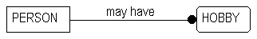
Figure 5.1: Example of characteristic entity.

Associative: | Associative entities record multiple relationships between two or more entities. For example, if a PERSON can have multiple ADDRESSs, and an ADDRESS may be shared by many PERSONs, an ADDRESS-USAGE entity may be needed to describe the relationship between the PERSON and the ADDRESS. In this example, ADDRESS-USAGE is an associative entity. Associative entities carry information about the relationship. We will look further at this familiar example later in this chapter.
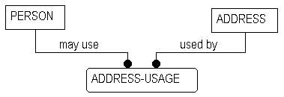
Figure 5.2: Example with associative entity.

Designative: | A designative entity is like an associative entity, except that it has no attributes of its own. In the preceding example, ADDRESS-USAGE could be a designative entity, if it held no information except for the identification of the PERSON and the ADDRESS (from the perspective of the PERSON, it "designates" the ADDRESS, and from the perspective of the ADDRESS, it "designates" the PERSON).
Category: | We introduced category entities briefly in Chapter 3. These are the dependent entities in a sub-category relationship. Category entities are the sub-types of the super-type in the subcategorization relationship. We will cover generalization hierarchies in more detail next.

Generalization Hierarchies & Inheritance
In Chapter 3 (Figure 3.11), we provided the following example of a generalization hierarchy.
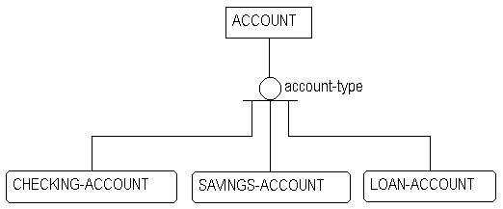
Figure 5.3: Example of generalization hierarchy.

Let's look at the process by which it was created. Let's presume that in developing a model, we have found the following three entities:
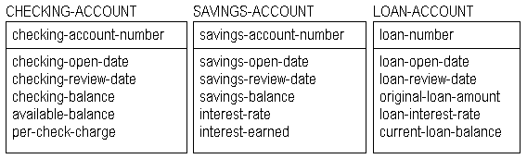
Figure 5.4: Example accounts.

As we were developing our individual models of different types of ACCOUNTs, we probably recognized some similarity among the different independent entities shown in Figure 5.4. What we will seek to do is to collect together attributes common to all three types of accounts into a hierarchical structure.
These common attributes will move into a higher level entity called the generic parent. Those which are specific to the individual account types will remain in the category entities.
Assume that we have not yet chosen the physical system keys for the three types of accounts. Here, we are working at a logical, or conceptual level.
First, we will form the generic parent, ACCOUNT and give it the key of "account-number." In order to distinguish one type of ACCOUNT from another, we add the attribute "account-type" as the category discriminator. Its value will tell us which category of ACCOUNT we have. Then we will add the three categories, CHECKING-ACCOUNT, SAVINGS-ACCOUNT, and LOAN-ACCOUNT.

Next, we compare the attributes of the three categories. Each has an "open-date." If the definitions of these three kinds of "open-date" are the same (we will assume that they are the same), we move them to the generic parent, and drop them from the categories. The same type of analysis moves "account-review-date."
All three categories have some sort of balance. CHECKING-ACCOUNT has two ("checking" and "available"). SAVINGS-ACCOUNT has one, and LOAN-ACCOUNT has two. Should we move them up to a generic parent?
Once again, the answer lies in the definitions. If we were to look closely, we might find that "checking-balance," "savings-balance," and "current-loan-balance" mean almost the same thing, but not quite (in which case they would stay with the category entities). Or, perhaps, we might find that "checking-balance" and "savings-balance" were the same, but "current-loan-balance" was very different.
In those cases where almost all of a set of attributes like this are the same, but a few are different, there are two options. Either leave the attributes with their categories, or move up the ones that are the same, and leave the others behind.

This will mean that the value of the generic parent attribute will be NULL when the category is one from which the attribute was not moved. Non-key attributes, unlike key attributes, are allowed to be NULL.
Which alternative to choose depends on how many of the categories share the common attribute. If most do, it is good practice, at higher level models, to move them up. If few categories share the attribute, it is best to leave them where they are. In lower level models, depending on the purpose, it is often appropriate to leave the attributes in their categories.
For the example, the balances were left where they were, leaving us with Figure 5.5. We determined that we would leave the rest of the attributes in the categories by determining from their definitions that they were, indeed, different things.
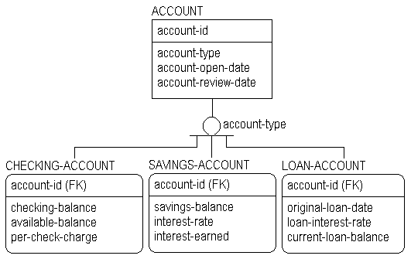
Figure 5.5: Completed account example.

Complete Versus Incomplete Category Structures
Different symbols are used to specify whether or not the set of categories of a generic parent is complete. Figure 5.6 shows an incomplete structure (indicating that there may be other categories which have not yet been discovered). Here we see that an EMPLOYEE is either a CONSULTANT or a FULL-TIME-EMPLOYEE. The single line at the bottom of the category symbol indicates that there may be other categories that are not included.
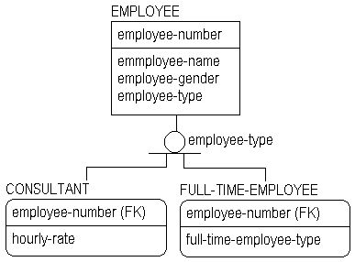
Figure 5.6: Incomplete category structure.

Figure 5.7 shows a complete structure. Here an EMPLOYEE is either a MALE-EMPLOYEE, or a FEMALE-EMPLOYEE.
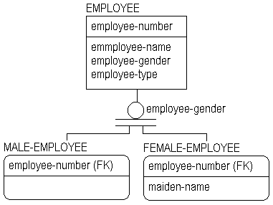
Figure 5.7: Complete category structure.

Figure 5.8 shows a combination of complete and incomplete category structures. Here, our EMPLOYEE is either a FULL-TIME-EMPLOYEE or a CONSULTANT, and at the same time, is either a MALE-EMPLOYEE or a FEMALE-EMPLOYEE.
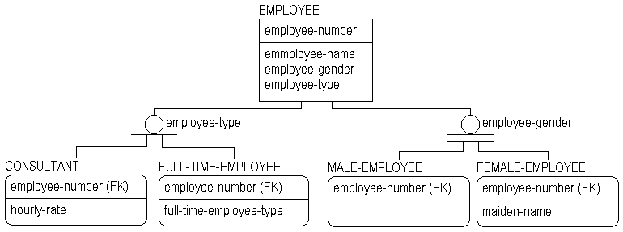
Figure 5.8: Example with a combination of complete & incomplete structures.

Figure 5.9 continues to extend the structure. Here another level of categories is added below FULL-TIME-EMPLOYEE, and a BENEFIT-ACCOUNT (with categories) is also added.
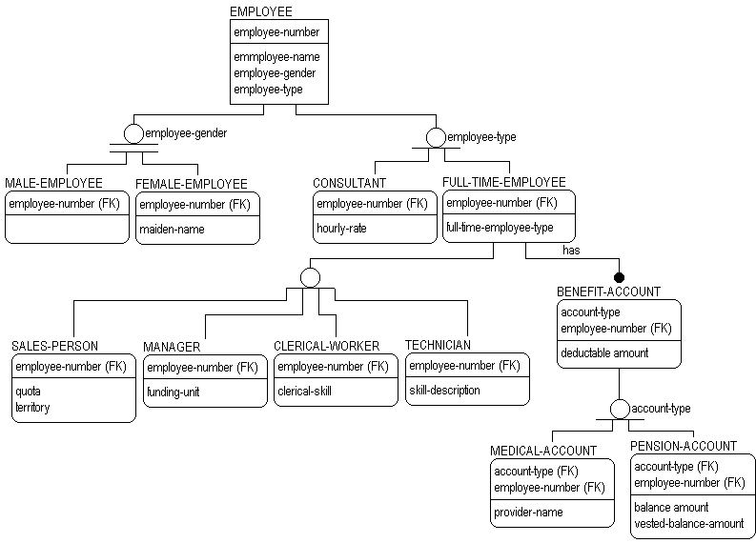
Figure 5.9: Example with many combinations of complete & incomplete structures.

When to Form a Generalization Hierarchy
To summarize, there are three reasons to form a generalization hierarchy.

- First, the entities share a common set of attributes. This was the case in our examples above.
- Second, the entities share a common set of relationships. We have not explored this, but, referring back to our account structure, we could as needed, collect any common relationships that the category entities had into a single relationship from the generic parent. For example, if we found in the individual structures that each type of account was related to many CUSTOMERs, we could create a single relationship (to many CUSTOMERs) at the ACCOUNT level, and eliminate the separate relationships from the individual categories.
- Third, categories of an entity should be exposed in a model if the business demands it (usually for communication or understanding purposes) even if the categories have no attributes which are different, and even if they participate in no relationships distinct from other categories. Remember that one of the major purposes of a model is to assist in communication of information structures, and if showing categories assists with this, then show them. Be careful, however, that you don't overdo it, and loose the overall meaning of the model in a web of detailed category structures.

More on Attributes
Suppose that we wanted to add the name of the customer who owns the account to the above example. Let's do it the way that most banks used to do it, as an attribute of the account (before they started to build their central customer information files and link them to the accounts). Suppose also that we want to be able to look up an account by the name of the customer, as well as the account number. We would build a diagram like this:
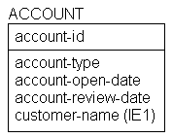
Figure 5.10: Entity with an inversion entry.

There is something new here. Note the (IE1) following the "customer-name" attribute.

Inversion Entry Attributes
An inversion entry represents an additional way in which the business wants to access the data. An inversion entry is an attribute or group of attributes which will commonly be used to access the entity, but may not result in finding exactly one instance. "Customer-name" is such attribute in the example above. By "customer-name" we may get to zero, one or more ACCOUNTs (remember that there may be more than one John Smith).

Related Topics:

Inversion Entry Notation

Derived Attributes
Derived attributes are those which may be computed from other attributes (e.g., totals) and therefore need not be stored directly. As you will see in Chapter 6, the recording of a derived attribute in a data model is a normalization error. A goal of normalization is to ensure that there is only one way to know each fact recorded in the data base. If we know the value of a derived attribute, and we know the algorithm by which it is derived and the values of the attributes used by the algorithm, then there are two ways to know the fact (look at the value of the derived attribute, or derive it from scratch). If you can get an answer two different ways, it is possible that the two answers will be different.

For example, suppose that we were to record both the "birth-date" and the "age" for one of our EMPLOYEEs. And suppose that the "age" attribute was only changed in the database during an end of month maintenance job. Then, when we asked the question, "How old is such and such EMPLOYEE?" we could directly access "age" and get an answer, or we could, at that point, subtract "birth-date" from "today's-date." If we did the subtraction, we would always get the right answer. If "age" has not been updated recently, it might give us the wrong answer, and there would always be the potential for conflicting answers.

There are situations, where it makes sense to record derived data in the model, particularly if the data is expensive to compute. It can also be very useful in discussing the model with the business. Although the theory of modeling says that you should never include derived data (and we urge you to do so only sparingly), break the rules when you must. But at least record the fact that the attribute is derived and state the derivation algorithm.

Relationship Types & Cardinality
Relationships are a bit more complex than they might at first seem. They carry a lot of information. Some might say that they are the heart of the information model, because, to a great extent, they describe the rules of the business and the referential integrity constraints.

Related Topics:

Cardinality
Relationship Type Details: One-to-Many, Identifying
One-to-Many, Non-identifying
Recursive Relationships

Cardinality
Relationships have a property called cardinality which defines how many of each participating entity may, or must, participate. Cardinality statements designate "how many" instances of the parent entity are connected to "how many" instances of the child.
The relationship symbol near the dot displays cardinality in graphic form.
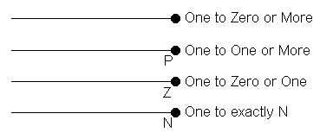
Figure 5.11: Cardinality notation.

In key-based and fully-attributed models, all relationships are "(zero or) one to something." Any many-to-many relationship must be broken down into a pair of one-to-many relationships. These model levels are discussed in Chapter 7.

Relationship Type Details: One-to-Many, Identifying
We saw a lot of identifying relationships in Chapters 2 and 3. Look again at Figure 3.8, the MOVIE / MOVIE-COPY example. It is repeated here with a slight modification as Figure 5.12.
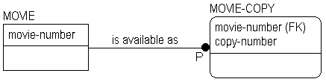
Figure 5.12: One-to-many identifying relationship.

In this example, a MOVIE-COPY cannot be identified unless the identifier of the MOVIE is known, (the "movie-number"). One of the basic principles of relational modeling as supported by ERwin, is that an instance of an entity cannot exist if it cannot be uniquely identified. MOVIE-COPY is existence-dependent on MOVIE.
This means something to our cardinality statement. It means that, on the end of the relationship without the dot, there will be exactly one MOVIE. How about the MOVIE-COPY end (the one with the dot)?
In our video store we defined a MOVIE-COPY as one of perhaps several reproductions of an original that we had available for rent. The business rule says that a MOVIE must have some non-zero number of copies. In short, "available as" is a one-to-one or more relationship. The "P" symbol next to the dot says this. A MOVIE with no copies is not a legitimate business object in this database.

Suppose, however, that we are constructing a model of a different video store, and this store has a different policy regarding things they are interested in keeping track of. They do care to know about all of the MOVIEs in the world, even those for which they have no copies. So their business rule is that for a MOVIE to exist (be recorded in their information system) there need not be at least one copy.
To record this business rule, the "P" is removed. This then becomes a one-to-zero, one or more relationship.
(As you will find, there are advantages to contributing keys to a child entity through identifying relationships in that it tends to make some physical system queries more straightforward, but there are also many disadvantages. Some advanced relational theory suggests that contribution of keys should not occur in this way. Instead, each entity should be identified not only by its own primary key, but also by a logical handle or surrogate key, never to be seen by the user of the system. There is a strong argument for this in theory and those who are interested are urged to review the work of E. F. Codd and C. J. Date in this area.)

One-to-Many, Non-identifying
Non-identifying relationships contribute keys from a parent to a child. But, by definition, some (or all) of the keys do not become part of the key of the child. This means that the child will not be identification-dependent on this parent. And there can be situations where an entity at the "many" end of the relationship can exist without a "parent," i.e., it is not existence-dependent.
If the relationship is mandatory from the perspective of the child, then the child is existence-dependent on the parent. If it is optional, the child is neither existence nor identification-dependent with respect to that relationship (although it may be dependent in other relationships). ERwin uses a diamond to indicate the optional case. Diamonds can only exist for non-identifying relationships (since an identifying relationship contributes a primary key, and no part of a primary key can be NULL). A non-identifying relationship with a diamond is a "zero or one-to-many" relationship. Here is a simple example.

In Figure 5.13, the attribute "passenger-id" became a foreign key attribute of SEAT. It doesn't identify the SEAT. It identifies the PASSENGER occupying the SEAT. Since the SEAT can exist without any PASSENGER, the relationship is optional and we use the diamond symbol.
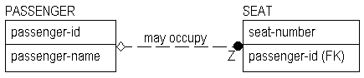
Figure 5.13: One-to-many, non identifying relationship.

We have declared that a PASSENGER <may occupy> zero or one of these SEATs on a flight.

A SEAT could be empty (not occupied by any PASSENGER). When the SEAT is empty, the "passenger-id" attribute will be empty (NULL). If, by business policy (or in this case by necessity since the airline cannot force passengers to fill every seat on every flight), this can be allowed to happen, the relationship is, from the perspective of the child entity, optional. The diamond at the parent end of the relationship signifies this. Aside from the diamond, the cardinality graphics for non-identifying relationships are the same as those for identifying relationships.

Recursive Relationships
An entity can participate in a recursive relationship (also called "fish hook") in which the same entity is both the parent and the child. Any recursive relationship must be non-identifying.

Figure 5.14 shows such a situation. Here, a COMPANY is shown to be the "parent of" other COMPANYs. As with all non-identifying relationships, this one brings the key of the parent entity into the data area of the child entity.
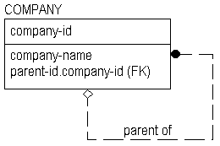
Figure 5.14: Example of a recursive relationship.

But notice that two other things have happened here. First, the name of the key is changed when it appears in the data area. Rather than being simply "company-id" it appears as "parent-id.company-id." The attribute "parent-id" is a rolename for "company-id."

An attribute cannot appear twice in the same entity under the same name. This would be an error in normalization (see Chapter 6). One of the basic principles of normalization is that if two things have the same name, they are the same thing.
The "company-id" identifier of the COMPANY is not the same thing as the identifier of the COMPANY that is the "parent of" this COMPANY. It is not defined the same, and although it comes from the same domain, it will have a different value (it points to a different COMPANY). Definitions and sample instance tables will help.

company-id: | The unique identifier of a COMPANY.
parent-id: | The "company-id" of the parent COMPANY. Not all COMPANYs have a parent COMPANY.
Perfecting these definitions is left to the reader. For example, what does the term "parent" mean? Owner? COMPANY that started the other, and spun it off? See Chapter 4 for more on definitions.
Here is a sample instance table:
COMPANY

company-id | parent-id | company-name
C1 | NULL | Big Monster Company
C2 | C1 | Smaller Monster Company
C3 | C1 | Other Smaller Company
C4 | C2 | Big Subsidiary
C5 | C2 | Small Subsidiary
C6 | NULL | Independent Company
Figure 5.15: Sample instance table for COMPANY.

From our sample instance table we see that "Big Monster Company" is parent of "Smaller Monster Company" and "Other Smaller Company." "Smaller Monster Company," in turn, is parent of "Big Subsidiary" and "Small Subsidiary." "Independent Company" is not the parent of any other, and has no parent. "Big Monster Company" also has no parent.
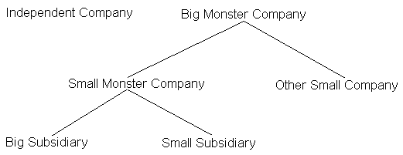
Figure 5.16: Company hierarchy.

Our previous diagram shows the diamond symbol indicating that the foreign key can be NULL when a COMPANY has no parent. Recursive relationships may be optional (diamond), or mandatory (no diamond).
Why are recursive relationships called "fish hooks"? Well, they look a bit like them. In its very early days, the dot signifying the many end of a relationship used to be an arrow head. They looked even more like fish hooks then. But arrows seemed to cause people to try to read the models as flow diagrams, which led to a lot of confusion. So arrow heads became dots. People still try to read information models as flow diagrams at first, but at least the graphics no longer encourage this.

Many-To-Many Relationships
Consider the following diagram. We saw something like it in Chapter 3, and used this example in our discussion of definitions in Chapter 4.

Related Topics:

Turning Many-to-many into One-to-many Relationships
Reading Many-to-many Relationships
N-ary Relationships

Turning Many-to-many into One-to-many Relationships
Figure 5.17 shows a situation in which there appears to be a many-to-many relationship between a PERSON and an ADDRESS. Moreover, it seems to say that the relationship is identifying in both directions.
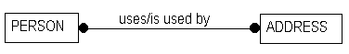
Figure 5.17: Many-to-many relationship.

There is nothing wrong with this, from a conceptual point of view, provided we are simply trying to say that a PERSON <uses> many ADDRESSs, and an ADDRESS <is used by> many PERSONs. Indeed, there is a level of model (the Entity Relationship Diagram (ERD) level) in which this is allowed to occur. At the ERD level, we don't worry about keys.
A many-to-many relationship (a solid line with dots on both ends) is called a non-specific relationship.
In the world of keys, such relationships don't make sense. If we apply what we have learned so far about identifying relationships to Figure 5.13, we will discover that the key of PERSON must be part of the key of ADDRESS and that the key of ADDRESS must be part of the key of PERSON. But ADDRESSs are identified by their own keys, and likewise for PERSONs. Oops. We have an endless loop!

In its formal levels, IDEF1X, unlike some other modeling languages, insists that all relationships be binary, i.e., that they connect exactly two entities. This does not mean that three, four, or "n-ary" relationships are not needed, only that these situations are adequately addressed with another construct ?the associative entity.
We still need to be able to record the many to many relationship. But how? We saw how to do this in Figure 3.10. Let's look at it again in more detail.
We have added an associative entity called ADDRESS-USAGE, and turned the many-to-many relationship into a pair of one-to-manys. Let's follow the keys.
The key of PERSON ("person-id") migrates to the associative entity, and so does the key of ADDRESS ("address-id"). These are not the only attributes of ADDRESS-USAGE. Notice the third part, "usage-type."
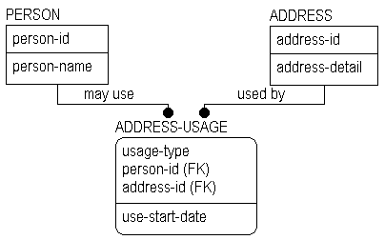
Figure 5.18: Associative entity.

Many-to-many relationships often hide meaning. In figure 5.17, we could see that PERSONs used many ADDRESSs, but we couldn't see how they were used. In the full structure in Figure 5.18, we can now see the "how." The attribute "usage-type" will tell us. Why is this attribute in the key area, and not in the data area?

Again, we cannot know unless we ask the business. If it were the case that a single PERSON could use a single ADDRESS in only a single way, then "usage-type" could be in the data area, and we could still tell how the address was used. But suppose that a single PERSON can use the same ADDRESS in many ways (e.g., as a mailing address, a residence address). If "address-usage" was not in the key area, there would be no way to record this information. Sample instance tables will help.

ADDRESS
address-id | address-detail
A1 | Princeton
A2 | New Brunswick
A3 | Berkeley 1
A4 | Berkeley 2
A5 | New York City

PERSON
person-id | person-name
P1 | Ben
P2 | Margaret
P3 | Tom
P4 | John
P5 | Leon

ADDRESS-USAGE
person-id | address-id | usage-type | use-start-date
P1 | A1 | business | 01 Jun 88
P1 | A2 | residence | 15 Sep 86
P1 | A2 | mailing | 15 Sep 86
P2 | A1 | business | 01 Jan 89
P3 | A1 | business | 01 Feb 89
P3 | A3 | residence | 15 May 75
P3 | A3 | mailing | 01 Jun 75
P3 | A4 | mailing | 01 Mar 89
P4 | A5 | residence | 30 Sep 87
Figure 5.19: Sample instance table for ADDRESS-USAGE.

And so will definitions. For the sake of this discussion:

PERSON: | Someone who we want to keep track of.
ADDRESS: | A place at which a PERSON can be contacted.
ADDRESS-USAGE: | The recording of a way in which a PERSON uses an ADDRESS.
We can see from our examples that Ben uses two addresses, Princeton and New Brunswick. In addition, he uses New Brunswick in two different ways, as residence and mailing addresses. Tom has a similar situation for Berkeley.
If "usage-type" is not part of the key of ADDRESS-USAGE, then there can be only a single instance which pairs Ben with New Brunswick (P1/A2). That would mean (with "usage-type" in the data area) that only one "use" of New Brunswick could be recorded. Which one? Residence, or mailing?

One might argue that if residence is indicated, then mailing can be assumed. But that doesn't seem to be the case for John in New York (P4/A5). Any assumption we make is likely to cost us!

You will find that sample instance tables can often save you from devising incorrect model structures. Their use for validation of structures is highly recommended.

Reading Many-to-many Relationships
Let's return to our example of a Person's use of an ADDRESS (Figure 5.18), and see if we can finally read the relationships. We ran into trouble here earlier.
There is a dilemma here for the modeler, as there are two ways to construct the verb phrases that accompany the diagram. Figure 5.18 is difficult to read unless you read the relationship through the associative entity to the entity on the other side. If you read through ADDRESS-USAGE, then you can come up with reasonable statements, in this case "An ADDRESS <is used by> one or more PERSONs ," and "A PERSON <may use> one or more ADDRESSs." These, at least, are readable statements. Many modelers adopt this style for constructing and reading a model.
There is another style, which is equally correct, but a bit more cumbersome. The structure of the model is exactly the same, but the verb phrases are different, and the model is "read" in a slightly different way. An example is provided in Figure 5.20.
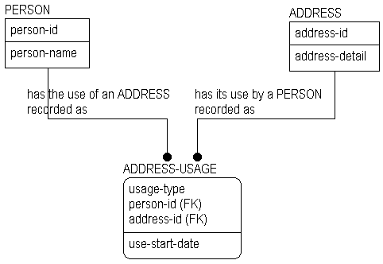
Figure 5.20:

Here is how we read it:

"A PERSON <has the use of an ADDRESS recorded as> one or more ADDRESS-USAGEs". "An ADDRESS <has its use by a PERSON recorded as> one or more ADDRESS-USAGEs."

Notice that the verb phrases have gotten fairly long, but that the reading follows our standard pattern reading directly from the parent entity to the child.
Whichever style you choose, be consistent. Deciding how to record verb phrases for many-to-many relationships is not too difficult when the structures are fairly simple, as in our examples. However, this can become more difficult when the structures become more complex. Sometimes the entities on either side of the associative entities are themselves associative entities, which are there to represent other many-to-many relationships.
As you become familiar with the modeling methods which we have described in this Chapter, and apply them to "real" projects you will begin to understand the dilemma we are describing, and will undoubtedly develop your own style for addressing it.

N-ary Relationships
All of the relationships we have been discussing have been binary relationships, i.e., our relationship line has connected exactly two entities. We have, in addition, separated out many-to-many relationships into a pair of one-to-manys. How do we represent a relationship among three or more entities?
We do it in a way which is similar to our associative entity. The relationship line does not connect the three (or more) entities. Rather, our "n-ary" relationship is represented as a set of binary relationships to an associative entity.
Consider the business rule stated by the diagram shown in Figure 5.21.
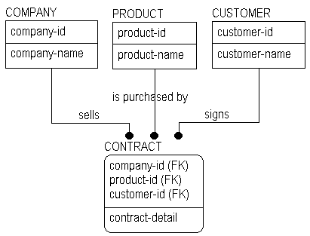
Figure 5.21: Three-way relationship.

Here we see that a CONTRACT represents a three-way relationship among COMPANY, PRODUCT, and CUSTOMER. The structure indicates that many COMPANYs sell many PRODUCTs to many CUSTOMERs (presumably, we are a service bureau here, and our data model represents the requirements for keeping track of many companies' products and customers).
Four-way, five-way, etc. relationships can be constructed in a similar way.
However, when you see a relationship like this, there are business questions begging to be asked. For example, "Must a product be offered by a company before it can be sold?" "Can a customer establish a single contract including products from several different companies?" and, "Do we need to keep track of which customers "belong to" which companies?" Depending on the answers, the structures may change.

If, for example, the answer to the question is "must a product be offered by a company before it can be sold?" is "yes," and the answers to the second and third are "no," then we would have to change the structure as in Figure 5.22.
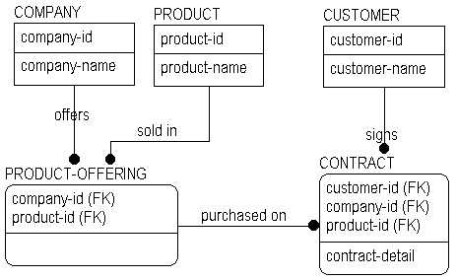
Figure 5.22: Altered model construct from 5.21.

Notice that our "three-way" relationship is now gone, and has been replaced by two two-way relationships. By asking these kinds of business questions, it is likely that you will find that the "n-ary" relationships will break down into a series of two-way ones. It is rare to see a "real" three way relationship in an IDEF1X model. It is even more rare to see "fours," "fives" and so on.

Rolenames & Assertions
A rolename is something more than a new name for an attribute. In Chapter 4, we saw that a role-named attribute had a definition which was different from the definition of the base attribute, and that the rolename was intended to describe the role (purpose) that the attribute plays (Section 4.5). Rolenames also carry with them assertions concerning the identity of the entity instance represented by the rolename(s).
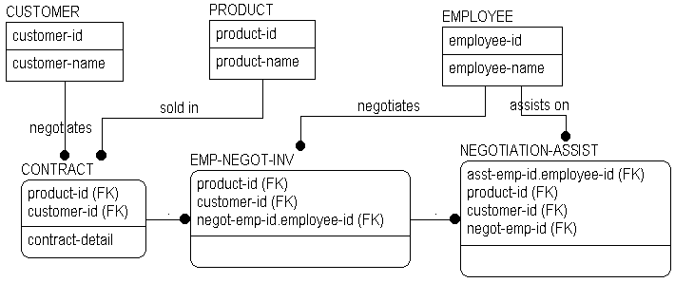
Figure 5.23: Rolename example.

If we look at the keys of NEGOTIATION-ASSIST. Here we can see two different rolenames, "negot-emp-id" and "asst-emp-id" for "employee-id" The assertion here is that when there is assistance of some sort, the "assisting" employee is not the same individual as the "negotiating" employee. Because two different EMPLOYEES are involved, two separate attributes are required to hold the identifiers. Our rolenames have specified this for us.
If you see a situation where contributed foreign keys coming from two different relationships have the same name, it is a good idea to closely inspect the structure for possible normalization errors. Chapter 6 covers the basics of normalization.

Existence & Identification Dependency

Relationship Descriptions & Insert, Replace, Delete (IRD) Rules
We have already covered several aspects of relationships. We have looked at cardinality (how many instances of each entity may participate in the relationship) and we have looked at verb phrases which allow us to read the model. There is one more important aspect of the recording of a relationship -- the insert, replace, and delete (IRD) rules. What follows is not a formal part of the IDEF1X language.
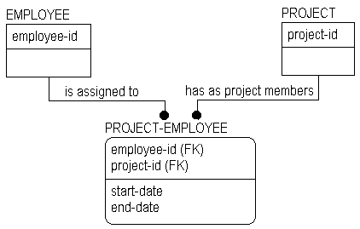
Figure 5.24: IRD example.

In this example, there is an identifying relationship between PROJECT and PROJECT-EMPLOYEE. The primary key of PROJECT becomes a part of the primary key of PROJECT-EMPLOYEE. Our cardinality rules say that for each instance of PROJECT-EMPLOYEE there is exactly one instance of PROJECT. The identifying nature of the relationship specifies that PROJECT-EMPLOYEE is existence-dependent on PROJECT.
What would happen if we were to delete an instance of PROJECT?
We would also have to delete all instances of PROJECT-EMPLOYEE which inherited part of their key from the deleted PROJECT. Why? Because a part of the key would become NULL, and NULL is not allowed as the value of any of the constituent parts of a primary key.

Delete Rules
So we have two choices: delete every instance of PROJECT-EMPLOYEE which inherited the key of the deleted instance of PROJECT, or prevent the deletion of the PROJECT if there are any PROJECT-EMPLOYEEs which would end up with incomplete keys. These situations relate to the delete rules called cascade and restrict, and the decision about which rule to use can be recorded in the model.
Cascade indicates that all instances of PROJECT-EMPLOYEE which are affected by the deletion of an instance of PROJECT should also be deleted. Restrict indicates that an PROJECT cannot be deleted until all instances of PROJECT-EMPLOYEE that have inherited its key have been deleted. If there are any left, the delete is "restricted."
Why would we want to restrict the deletion? One reason might be that we need to know other facts about a PROJECT-EMPLOYEE such as the "date started" on the project. If we were to cascade the delete, we would lose this supplementary information. Besides restricting the deletion, if we decide that PROJECT-EMPLOYEEs are not existence or identification-dependent on PROJECT, we can change the referential integrity constraint by using an optional non-identifying relationship between the two entities.
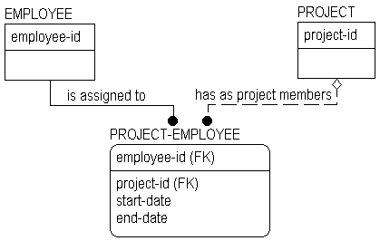
Figure 5.25: Example with non-identifying relationship.

In this case, the IRD situation is a bit different. As we already know, a foreign key contributed across a non-identifying relationship is allowed to be NULL (remember the diamond?). So for a non-identifying relationship we have a third option called set null. Set null indicates that if an instance of PROJECT is deleted, and the key of PROJECT is held as data about a PROJECT-EMPLOYEE, then this foreign key should be set to NULL in the PROJECT-EMPLOYEE. The delete does not cascade as in our previous example, and we do not prohibit the delete (as in restrict). We set the key to NULL. The advantage of this approach is that we can preserve the information about the PROJECT-EMPLOYEE while effectively breaking the connection between the PROJECT-EMPLOYEE and PROJECT.

Insert & Replace Rules
Using IRD Rules is an additional way to record the rules of the business. Decisions to use cascade or set null reflect business decisions about maintaining the "historical" knowledge of relationships represented by the foreign keys.

As we have just seen, delete rules govern what will happen in a database when a row in a table is deleted. Insert and replace rules govern what will happen when a row is added or changed. Insert and replace rules are explicitly stated in the model already. They are stated by the relationship types themselves.

For insert, a row can be added only if all referenced foreign keys match existing rows in the referenced tables, unless the relationship explicitly states otherwise (i.e., the diamond on the non-identifying relationship). A replace is, in effect, an insert so the same rules apply.
Let's look at an example. In our MOVIE / MOVIE-COPY diagram, MOVIE-COPY holds the key of a corresponding MOVIE. Therefore, we cannot insert a MOVIE-COPY for which there is no MOVIE. The "P" on the relationship also tells us that we cannot insert a MOVIE without also inserting a MOVIE-COPY.
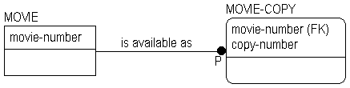
Figure 5.26: Example for insert and replace rules.

Normalization

Introduction
The goal of normalization is to ensure that there is only one way to know a "fact." The process of normalizing a model is one of removing all model structures that provide multiple ways to know the same fact. Another way to look at normalization is as a method of controlling and eliminating redundancy in data storage.
A useful slogan summarizing the goal of normalization is:

ONE FACT IN ONE PLACE!

To provide a basic understanding of the principles of normalization, we will use some examples of obvious (and not so obvious) design problems. Normalization is a very important part of good database design. In this brief chapter, we can only provide an overview. Readers who are interested in a more complete treatment of the subject, are urged to see the work of C. J. Date and many others.

Common Design Problems
Repeating Data Groups
There is something wrong with the model shown in Figure 6.1. Can you see what it is?
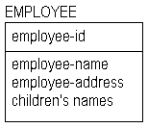
Figure 6.1: Employee entity.

A sample instance table might help.
EMPLOYEE
emp-id | emp-name | emp-address | children's-names
E1 | Tom | Berkeley | Jane
E2 | Don | Berkeley | Tom, Dick, Donna
E3 | Bob | Princeton | ------
E4 | John | New York | Lisa
E5 | Carol | Berkeley | ------
Figure 6.2: EMPLOYEE instance table.

You probably saw the problem without the table. It lies with the attribute called "children's-names."
In our discussions of entities and attributes, we said that all names must be singular. Here we see one which is not. The obvious questions might be, "How many children's names do we need to record?" "How much space should we leave in each row in the database for the names?" and "What will we do if we have more names than remaining space?"
This design is a violation of what is called First Normal Form. First normal form is a basic definition of the "shape" of a design. It says that the rows and columns of our data must form a two-dimensional table with no nested structure inside any cell. Every data value in our database must be atomic with no lists, repeating elements or internal structure. (Think of each value in a column as a single entry in a "cell" in a spreadsheet such as Microsoft EXCEL or Lotus 1-2-3.)

In order to fix the design above, we must somehow remove the list of children's names. One way to do this is to convert the non-first normal form entity into the structure shown in Figure 6.3. Now we can represent the names of the children as single entries. (In terms of the physical record structure for employee, this may resolve several space allocation issues e.g., wasting space in the record structure for employees who have no children or conversely, deciding how much space to allocate for employees with families).
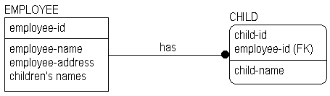
Figure 6.3: Altered model construct from Figure 6.1.

EMPLOYEE
emp-id | emp-name | emp-address
E1 | Tom | Berkeley
E2 | Don | Berkeley
E3 | Bob | Princeton
E4 | John | New York
E5 | Carol | Berkeley

CHILD
emp-id | child-id | child-name
E1 | C1 | Jane
E2 | C1 | Tom
E2 | C2 | Dick
E2 | C3 | Donna
E4 | C1 | Lisa
Figure 6.4: Sample instance table for Figure 6.3.

We have discovered a group of repeating data and have broken it out to a new entity. In doing so, we have taken the first step toward a normalized model. We have converted it into first normal form.

Multiple Use of the Same Attribute
Here is another example of a problem with a design. Can you see it?
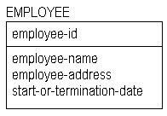
Figure 6.5: Example design error.

EMPLOYEE
emp-id | emp-name | emp-address | start-or-termination-date
E1 | Tom | Berkeley | Jan 10. 1988
E2 | Don | Berkeley | May 22, 1986
E3 | Bob | Princeton | Mar 15, 1985
E4 | John | New York | Sep 30, 1988
E5 | Carol | Berkeley | Apr 22, 1987
E6 | George | Pittsburgh | Oct 15, 1988
Figure 6.6: Sample instance table for Figure 6.5.

The problem, of course, is that we have a single attribute, "start-or-termination-date" which can represent one of two facts, and there is no way to understand which fact it represents. There is also no way to record both a start date, "the date that the EMPLOYEE started work," and a termination date, "the date on which an EMPLOYEE left the company," in situations where both dates are known.
The solution is not to require a single attribute to play double duty, but rather to allow separate attributes to carry separate facts. Below is our first attempt to correct the problem. It's still not quite right. Here, we have to derive what kind of date it is from the "date-type" attribute. While this may be efficient in terms of physical database space conservation, it wreaks havoc with query logic.
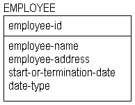
Figure 6.7: Improved model construct from Figure 6.5.

What we have done is create another type of normalization error (date-type does not depend on employee-id for its existence). These errors are sometimes easy to spot when we find an attribute carrying more than one fact.
This is a better way. All attributes carry separate facts.
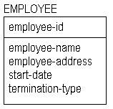
Figure 6.8: "Fixed" model construct from Figure 6.5.

EMPLOYEE
emp-id | emp-name | emp-address | start-date | termination-date
E1 | Tom | Berkeley | Jan 10.1988 | ------
E2 | Don | Berkeley | May 22,1986 | ------
E3 | Bob | Princeton | Mar 15,1985 | ------
E4 | John | New York | Sep 30,1988 | ------
E5 | Carol | Berkeley | Apr 22,1987 | ------
E6 | George | Pittsburgh | Oct 15,1988 | Nov 30, 1988
Figure 6.9: Sample instance table for Figure 6.8.

Each of the two situations which we have just seen was what is called a first normal form error. By changing the structures we have made sure that an attribute appears only once in the entity, and that it carries only a single fact. Here is a working definition for first normal form. We will provide more formal definitions a bit later.

Informal Definition: An entity is in first normal form if each of its attributes has a single meaning and not more than one value for each instance.
If you make sure that all entity and attribute names are singular, and that no attribute can carry multiple facts, then you will have taken a large step toward assuring that a model is in first normal form.

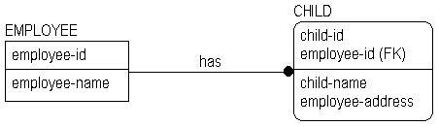
Multiple Occurrences of the Same Fact
Here is a structure with another problem:

Figure 6.10: Normalization error example.

If we were to place the "employee-address" attribute in the CHILD entity as shown in Figure 6.10, we might have an intuitive feeling that something was wrong. "Employee-address" is information about the EMPLOYEE, not information about the CHILD. Another way to say this is that the value of "employee-address" does not depend on the entire key of CHILD, only on part of it (the "employee-id" part).
By placing "employee-address" back with EMPLOYEE as we did in Figure 6.3, we ensured that the model is in at least second normal form.
An entity violates second normal form, if a fact can be determined by knowing only part of the key of the entity. If a fact can be known by knowing the value of some non-key attribute of the entity, then third normal form is violated.
For example, there would be a third normal form error if the entity CHILD in figure 6.10 contained both a "birth-date" and an "age" attribute as non-key attributes. "Age" is
functionally dependent on "birth-date." By knowing "birth-date" and the date today, we can derive the "age" of the CHILD.

To summarize the three normal forms we have the following rule. It has been attributed to Dr. E. F. Codd, the "father" of the Relational Model, although we doubt that he ever said it:

An entity is in third normal form if every non-key attribute depends on the key, the whole key and nothing but the key, so help me Codd!

Conflicting Facts
Continuing to look at normalization problems, consider the following diagram:
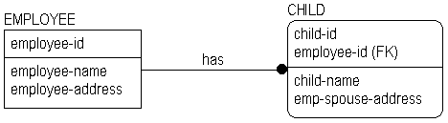
Figure 6.11: Normalization error.

EMPLOYEE
emp-id | emp-name | emp-address
E1 | Tom | Berkeley
E2 | Don | Berkeley
E3 | Bob | Princeton
E4 | John | New York
E5 | Carol | Berkeley

CHILD
emp-id | child-id | child-name | emp-spouse-address
E1 | C1 | Jane | Berkeley
E2 | C1 | Tom | Berkeley
E2 | C2 | Dick | Berkeley
E2 | C3 | Donna | Cleveland
E4 | C1 | Lisa | New York
Figure 6.12: Sample instance tables for Figure 6.11.
There are several problems here. Look first at the attribute named "emp-spouse-address." We should recognize this as, at least, a second normal form error.
In Figure 6.12, we see that Don is the parent of Tom, Dick, and Donna. But there is something strange about the "emp-spouse-address" entries for Tom, Dick, and Donna. There are two different addresses recorded for Don's spouse. Perhaps Don has two spouses (one in Berkeley, and one in Cleveland), or Donna has a different mother from Tom and Dick. Or perhaps Don has one spouse with addresses in both Berkeley and Cleveland. Or perhaps it's time to call in your local Data Administrator! Which of these is the answer? There is no way to know from the model as it stands.
The problem here is that "emp-spouse-address" is a fact about the EMPLOYEE's SPOUSE, not about the CHILD. If we leave the structure the way it currently is, then every time Don's spouse changes address (along with Don, we presume), we will have to update that fact in multiple places; once in each CHILD instance where Don is the parent. And if we have to do that in multiple places, what is the chance that we will always get it right everywhere? Not too good.

So the first thing we need to do is recognize that "emp-spouse-address" is a fact not about a CHILD but about a SPOUSE. Of course, we could come up with a rule that says that an "emp-spouse-address" is the same as "emp-address" and derive this information from the EMPLOYEE entity. But if we were to do this, there would be no way to record an address for a SPOUSE who is not living at the same address as the EMPLOYEE. So we need to make a change as in Figure 6.13.
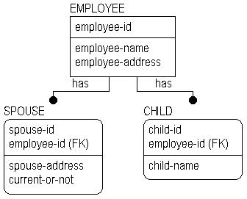
Figure 6.13: Spouse entity added to model construct displayed in Figure 6.11.

EMPLOYEE
emp-id | emp-name | emp-address
E1 | Tom | Berkeley
E2 | Don | Berkeley
E3 | Bob | Princeton
E4 | John | New York
E5 | Carol | Berkeley

CHILD
emp-id | child-id | child-name
E1 | C1 | Jane
E2 | C1 | Tom
E2 | C2 | Dick
E2 | C3 | Donna
E4 | C1 | Lisa

SPOUSE
emp-id | spouse-id | spouse-address | current-or-not
E2 | S1 | Berkeley | Y
E2 | S2 | Cleveland | N
E3 | S1 | Princeton | Y
E4 | S1 | New York | Y
E5 | S1 | Berkeley | Y
Figure 6.14: Sample instance table for Figure 6.13.

In breaking out SPOUSE into a separate entity, we have gained the ability to recognize that there was no error in the data for Don's spouse's address. Indeed, there were two spouses, one current, and one not (former, it seems).
By making sure that every attribute in an entity carries a fact about that entity, you can generally be sure that a model is in at least second normal form. Transforming a model into third normal form generally reduces the likelihood that the database will become corrupt, i.e., that it will contain conflicting information, or that required information will be missing.

Missing Information
When we changed our diagram from Figure 6.11 to Figure 6.13, we might have lost something that we assumed we knew. The reason that "emp-spouse-address" was stored in the CHILD entity in the first place might have been an attempt to represent the address of the other parent of the child (which was assumed to be the spouse). If we need to know the other "parent" of each of the children, then we must add this information to the CHILD entity.
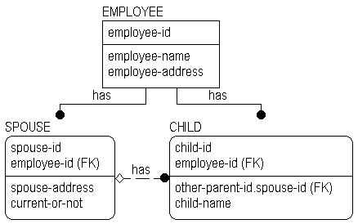
Figure 6.15: Replaced "missing data" example.

EMPLOYEE
Emp-id | emp-name | emp-address
E1 | Tom | Berkeley
E2 | Don | Berkeley
E3 | Bob | Princeton
E4 | John | New York
E5 | Carol | Berkeley

CHILD
emp-id | child-id | child-name | other-parent-id
E1 | C1 | Jane
E2 | C1 | Tom | S1
E2 | C2 | Dick | S1
E2 | C3 | Donna | S2
E4 | C1 | Lisa | S1

SPOUSE

emp-id | spouse-id | spouse-address | current-or-not
E2 | S1 | Berkeley | Y
E2 | S2 | Cleveland | N
E3 | S1 | Princeton | Y
E4 | S1 | New York | Y
E5 | S1 | Berkeley | Y
Figure 6.16: Sample instance table for Figure 6.15.

Unification
The situation above is a good example of what is referred to in ERwin as unification. This is an advanced topic, and only more experienced modelers will need to know this. For those who are interested, here is a general discussion of the principles involved.
In Figure 6.15, we contributed the primary key of SPOUSE across the "has" relationship to CHILD. Since the attribute "employee-id" was already present in the key area of CHILD, it is not repeated in the data area, even though it is part of the key of SPOUSE.
Here is what we did to cause this to occur. In the Entity-Attribute Editor, we saw that "employee-id" was part of the primary key of CHILD (contributed by the "has" relationship from EMPLOYEE), and was also a non-key attribute of CHILD (contributed by the "has" relationship from SPOUSE). The situation is highlighted with the arrows pointing to the attributes.
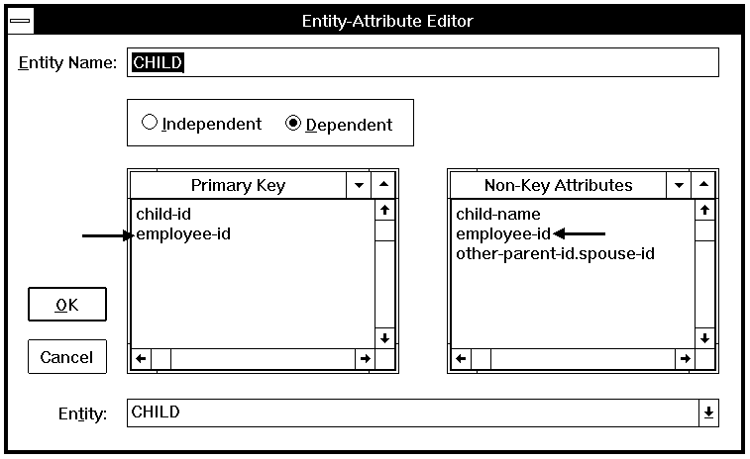
Figure 6.17: ERwin Entity-Attribute Editor for CHILD.

We made the decision that these were the identifiers of the same EMPLOYEE, and did not, therefore, assign separate rolenames for them. Because we did not assign them distinct rolenames, ERwin then "unified" them for us. Normally, unification is indicated by explicitly assigning different foreign keys the same rolename. Foreign keys must have migrated from the same base attribute for unification to occur.
If we follow the logic of what happens as the keys migrate, we will see that, at first, the full identifier of SPOUSE "comes into" the data area of CHILD. But since an attribute can appear in an entity only once under a given name, the two occurrences of "employee-id" unify, i.e., they become one. Since "employee-id" is necessary to uniquely identify a CHILD, the unified attribute remains in the key area. Because it occurs only once, "spouse-id" remains in the data area of CHILD.
Business rules can be stated with unification. In this case, the rule is that the SPOUSE which is the parent of the CHILD must be the spouse of the EMPLOYEE which is the other parent of the CHILD. We also could have specified that a CHILD could have a parent who was the SPOUSE of another EMPLOYEE.

Unification is controlled by the assignment of rolenames.

Related Topics:

Rules for unification
Back to the example...
Alternate structures

Summary of the Normal Forms
This chapter has focused on unfolding an example of a data-base design, and, one by one, removing normalization errors. The following are formal definitions for the six normal forms.

Related Topics:

Functional Dependence (FD)
Full Functional Dependence
First Normal Form (1NF)
Second Normal Form (2NF)
Third Normal Form (3NF)

Functional Dependence (FD)
Given an entity E, attribute B of E is functionally dependent on attribute A of E if and only if each value of A in E has associated with it precisely one value of B in E (at any one time). In other words, A uniquely determines B.

Full Functional Dependence
Given an entity E, an attribute B of E is fully functionally dependent on a set of attributes A of E if and only if B is functionally dependent on A and not functionally dependent on any proper subset of A.

First Normal Form (1NF)
An entity E is in 1NF if and only if all underlying domains contain atomic values only.

Second Normal Form (2NF)
An entity E is in 2NF if it is in 1NF and every non-key attribute is fully dependent on the primary key. In other words, there are no non-full dependencies ?dependence is on the entire key K of E, and not on a proper subset of K.

Third Normal Form (3NF)
An entity E is in 3NF if it is in 2NF and no non-key attribute of E is dependent on another non-key attribute. There are several equivalent ways to express 3NF. Here is a second: An entity E is in 3NF if it is in 2NF and every non-key attribute is non transitively dependent on the primary key. A third and final way is: An entity E is in 3NF if every attri-bute in E carries a fact about all of E (2NF) and only about E (as represented by the entity's entire key and only by that key).
Beyond 3NF lie three more normal forms, Boyce-Codd, Fourth and Fifth. In practice, third normal form is the standard. At the level of the physical database design, choices are usually made to "denormalize" a structure in favor of performance for a certain set of transactions. This may introduce redundancy in the structure, but is often worth it.

ERwin Support for Normalization
ERwin provides some support for normalization of data models, but does not currently contain a full normalization algorithm. The following areas are addressed. If you have not used a "real time" modeling tool before, you will find these features quite helpful. They will prevent you from making many normalization errors in the first place.

Related Topics:

First Normal Form Support
Second and Third Normal Form Support

First Normal Form Support
In a model, each "object" (entity or attribute ) is identified by its "name." ERwin will accept any name for an object, with the following exceptions:

- ERwin will flag a second use of an entity name (depending on the "Unique Name" option setting).
- ERwin will flag a second use of an attribute name, unless that name is a rolename. When rolenames are assigned, the same name for an attribute may be used in different entities. See the above discussion of unification.
- ERwin will not let you bring a foreign key into an entity more than once without giving it a rolename each time.

By preventing multiple uses of the same name, ERwin is basically leading you to put each fact in exactly one place. There may still be second normal form errors if you place an attribute incorrectly, but no algorithm would find that without more information than is present in a model.
In the information model, ERwin cannot know that a name you assign to an attribute can represent a "list" of things. For example, ERwin was happy to accept "children's-names" as an attribute name in our earlier example. So it does not directly guarantee that every model is in first normal form.
However, the DBMS schema function of ERwin does not support a data type of "list." Because the schema is a representation of the database in a physical relational system, first normal form errors are also prevented at this level.

Second and Third Normal Form Support
ERwin does not currently know about functional dependencies, but it can help to prevent second and third normal form errors. For example, if you reconstruct the examples presented earlier in this chapter, you will find that once "spouse-address" has been defined as an attribute of SPOUSE, you cannot also define it as an attribute of CHILD. (Again, depending on your setting of the "Unique Name" option.)
By preventing the multiple occurrence of foreign keys without rolenames, ERwin is reminding you to think about what the structure represents. If the same foreign key occurs twice in the same entity, there is a business question to ask:

Are we recording the keys of two separate instances of another entity here, or do both of the keys represent the same instance?

When the foreign keys represent different instances, separate rolenames are needed. If the two foreign keys represent the same instance, then there is very likely a normalization error somewhere. A foreign key appearing twice in an entity, without rolenames, is a dead giveaway that there is a redundant relationship structure in the model. When two foreign keys are assigned the same rolename, unification occurs.

How Much Normalization Is Enough?
Let's pick up our example again. In Figure 6.20, we had determined that a PERSON could either be an EMPLOYEE or a SPOUSE, that EMPLOYEEs and SPOUSES were related, and that another relationship (CHILD) existed between two PERSONs. From a formal normalization perspective (what an algorithm would find solely from the "shape" of the model, without understanding the meanings of the entities and attributes) there is nothing wrong with this model. If a normalization algorithm was "smart" enough, it might recognize the presence of two similar relationships between two instances of the PERSON entity (CHILD and EMPLOYEE-SPOUSE-ASSOCIATION) and point it out to you. But it would have no way to understand that there is something similar between what we really mean by CHILD and what we really mean by PERSON.
Without an understanding of the meanings of the attributes and entities presented in the model, a normalization algorithm could probably not help you further. But an expert system could. ERwin has some built-in rules, but it is not an expert system, and does not currently contain a formal normalization algorithm.

This is the point where people take over. All sorts of junk will fit the rules of normalization. With experience, people begin to be able to detect and remove the junk. So lets see if we can get this right. Remember, pure normalization is finished, but the model is not.
As we proceed with testing our EMPLOYEE model with sample instance tables and real information about our business, we will soon discover that we have to make a few more changes. These have nothing to do with classical normalization. They have to do with creating a model which accurately describes the reality of the business.
For example, we soon discover that there is no way of recording a CHILD whose parents are both EMPLOYEEs. So we might make a change like that in Figure 6.22.
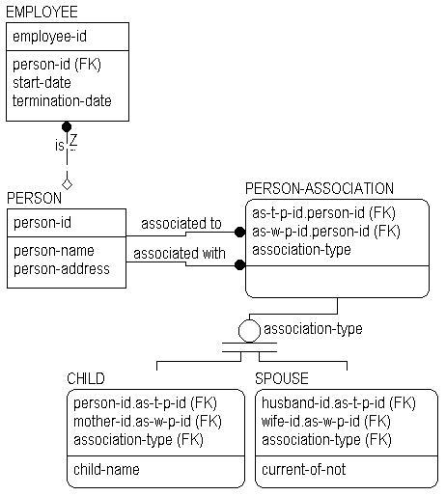
Figure 6.22: Second model solution for Figure 20.

PERSON
person-id | person-name | person-address
P1 | Carol | Berkeley
P2 | Jean | Berkeley
P3 | Clara | Cleveland
P4 | Margaret | Princeton
P5 | Lynn | New York
P6 | Tom | Berkeley
P7 | Jane | Berkeley
P8 | Don | Berkeley
P9 | Bob | Princeton
P10 | John | New York
P11 | George | Pittsburgh

EMPLOYEE
emp-id | person-id | start-date | termination-date
E1 | P1 | Apr 22, 1987 | ------
E2 | P4 | June 1, 1987 | ------
E3 | P6 | Jan 10. 1988 | ------
E4 | P8 | May 22, 1986 | ------
E5 | P9 | Mar 15, 1985 | ------
E6 | P10 | Sep 30, 1988 | ------
E7 | P11 | Oct 15, 1988 | Nov 30, 1988

PERSON-ASSOCIATION
as-w-p-id | as-t-p-id | association-type
P1 | P6 | spouse
P1 | P6 | child
P2 | P8 | spouse
P2 | P8 | child
P3 | P8 | former spouse
P3 | P8 | child
P4 | P9 | spouse
P5 | P10 | spouse
P5 | P10 | child
Figure 6.23: Sample instance table for Figure 6.22.

SPOUSE
wife-id.as-w-p-id | husband-id.as-t-p-id | association-type
P1 | P6 | spouse
P2 | P8 | spouse
P3 | P8 | former spouse
P4 | P9 | spouse
P5 | P10 | spouse

CHILD
mother-id.as-w-p-id | father-id.as-t-p-id | association-type | child-name
P1 | P6 | child | Jane
P2 | P8 | child | Tom ***
P2 | P8 | child | Dick ***
P3 | P8 | child | Donna
P5 | P10 | child | Lisa
Figure 6.23: Sample instance table for Figure 6.22, continued.

But in Figure 6.22, we would run into a problem in trying to record more than one CHILD with the same parents (notice the instances for Tom and Dick ?they both have the same key!). If we understood that the EMPLOYEE Tom was the same person as the CHILD Tom, we would see another problem. Again, we would soon recognize that we had to change the structure.
Figure 6.24 would be a step in the right direction. Now we could record multiple CHILDs for a pair of PERSONs. But we still have the problem that a CHILD is not a relationship between two PERSONs, like marriage. It is something that is a PERSON.

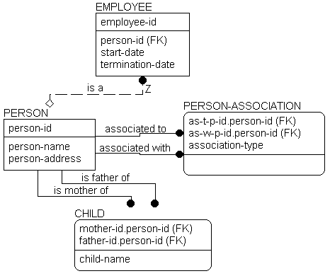
Figure 6.24: Alternative model construct to Figure 6.22.

So, in Figure 6.25, we will eliminate CHILD from the model, and record parentage through the relationship between two PERSONs called PERSON-ASSOCIATION. Now we finally have it!
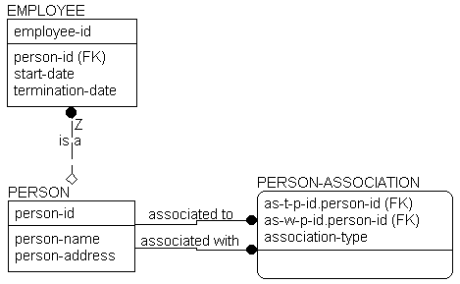
Figure 6.25: Completed model solution.

In this structure, we can finally record any number of relationships between two PERSONs. And we can record more than we could before. For example, we had not considered "adoption." Our new structure, however, automatically covers it. We simply add a new value to the domain of "person-association-type" to represent adopted parentage.
The full domain of our "association-type" is:

- Natural Father of

- Natural Mother of
- Adopted Father of
- Adopted Mother of
- Current Spouse of
- Former Spouse of

We could also add "legal guardian," "significant other," or other relationships between two PERSONs later, if needed.
We have left EMPLOYEE, the place where this all started, as an independent entity, because we intend (in this business anyway) to identify EMPLOYEE differently from PERSON. However, EMPLOYEE will inherit the properties of PERSON by virtue of the "is a" relationship back to PERSON. Notice the "Z" on that relationship and the absence of a diamond. This is a one-to-zero or one relationship that can sometimes be used in place of a generalization hierarchy when the categories require different keys. In our example, a PERSON either "is an" EMPLOYEE or not.
If we had wanted to use the same key for both PERSON and EMPLOYEE we could have "encased" the EMPLOYEE entity into PERSON and allowed its attributes to be NULL whenever the PERSON was not an EMPLOYEE. We still could have specified that the business wanted to look up "employees" by a separate identifier, but the business statements would have been a bit different. This structure is shown in Figure 6.26.
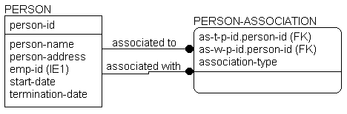
Figure 6.26: Generalized model construct.

Related Topics:

Conclusions

Conclusions
What this all basically comes down to in the end is that a model may "normalize," but may still not be a correct representation of the business. Formal normalization is important. Verifying, perhaps with sets of sample instance tables as we have done here, that the model means something is no less important.

Information Modeling Methodologies

Information Modeling Objectives
Throughout this document we have been discussing information modeling as the process of describing information structures and capturing business rules. Information modeling is a method for specifying information system requirements.
An information model will always represent a balance between the specific needs of a particular implementation project, and the general needs of the business area in which that project is being conducted.
Structured system development approaches in general, and data-centered design approaches specifically, invest heavily in front end planning and requirements analysis activities. Many of these "top-down" design approaches use information modeling as a method for identifying and documenting that portion of system requirements relating to data. Other models (e.g., Data Flow Diagram sets, Distribution Models, Event / State Models) are used to document processing requirements. Different levels of these models are used during different development phases.
When created with the full participation of business and systems professionals, the information model can provide many benefits. These benefits generally fall into two classes ?those primarily associated with the model (the product of the effort) and those associated with the process of creating the model (the effort).

Examples of product benefits:

- An information model is an unambiguous specification of what is wanted.
- The model is business user-driven. The content and structure of the model is controlled by the business client rather than the system developer. The emphasis is on requirements rather than constraints or solutions.
- The terms used in the model are stated in the language of the business, not that of the system development organization.
- The model provides a context to focus discussions on what is important to the business.

Examples of process benefits:

- During early project phases, model development sessions bring together individuals from many parts of the business, and provide a forum, with a high degree of structure, in which business needs and policies are discussed. During these sessions, it is often the case that business staff, for the first time, meet others in different parts of the organization who are concerned with the same needs.
- Sessions lead to development of a common business language with consistent and precise definition of terms used. Communication among participants is greatly increased.
- Early phase sessions provide a mechanism for exchanging large amounts of information among business participants, and transferring much business knowledge to the system developers. Later phase sessions continue that transfer of knowledge to the staff who will implement the solution.
- Session participants are generally able to better see how their activities fit into a larger context. Parts may begin to be seen in the context of the whole. The emphasis is on "cooperation" rather than "separation." Over time, this can lead to a shift in values, and the reinforcement of a cooperative philosophy.

- Sessions foster consensus and build teams.

Design of the data structures to support a business area is only one part of developing a system. The analysis of processes (function) is equally important. ERwin does not provide direct support for any particular process modeling style, but it can work well with many techniques. Function models describe "how" something is done. They can be presented as hierarchical decomposition charts, Data Flow Diagrams, HIPO diagrams, etc. You will find, in practice, that it is important to develop both your function and data models at the same time. Discussion of the functions to be performed by the system uncovers the data requirements. Discussion of the data normally uncovers additional function requirements. Function and data are the two sides of the system development coin.

ERwin Support for Modeling Methodologies
ERwin has been developed to support the IDEF1X modeling standard, but is otherwise free from restrictions on any methodology. The use of various levels of models for various purposes can, however, be very helpful in developing a system.
General model levels are outlined in the standard, and are presented below. In practice, you may find it useful to expand or contract the number of levels to fit individual situations.
The model levels generally trend from a very wide, but not too detailed view of the major entities that are important to a business, down to a level of precision required to represent the database design in terms understandable by a particular Database Management System (DBMS). At their very lowest level of detail, the models are said to be technology dependent, e.g., a model for an IMS database will look very different from a model for a DB2 database. At higher levels, the models are technology independent, and may even represent information which is not stored in any automated system.

The modeling levels presented below are well suited to a top-down system development life cycle approach, in which successive levels of detail are created during each project phase.
The highest level models come in two forms. The Entity Relationship Diagram (ERD) identifies major business entities and their relationships. The Key Based (KB) Model is a third normal form relational model which sets the scope of the business information requirement (all entities are included) and begins to expose the detail.
The lower level models also come in two forms. The Fully Attributed (FA) Model is a third normal form model which contains all of the detail for a particular implementation effort. The Transformation Model (TM) represents a transformation of the relational model into a structure which is appropriate to the DBMS chosen for implementation.
The transformation model, in most cases, is no longer in third normal form. The structures have been optimized based on the capabilities of the DBMS, the data volumes, and the expected access patterns and rates against the data. In a sense, this is an ERwin picture of the eventual physical database design.

The database design contains the DBMS Model for the system. Depending on the level of integration of a business' information systems, the DBMS Model may be a project level model, or an area level model for the entire integrated system.
These levels are presented in Figure 7.1. Notice that the DBMS Model can be either at an "Area" scope, or a "Project" scope. It would not be uncommon to have single ERD and KB models for a business, and multiple DBMS Models, one for each implementation environment, and then another set within that environment for "projects" which do not share databases. In an ideal situation, there are a set of "Area" scope DBMS Models, one for each environment, with complete data sharing across all projects in that environment.
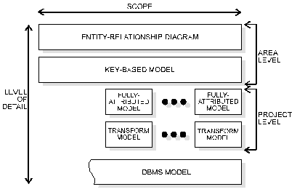
Figure 7.1: Database design levels.

Related Topics:

Area Information Models
The Key Based (KB) Model
The Project Information Models
The Fully-attributed (FA) Model
The Transformation Model

Area Information Models
An Area Information Model is an information model which covers a broad business area, and which usually is larger than the business chooses to address with a single automation project. There are two levels, the Entity Relationship Diagram (ERD) and the Key Based (KB) Model.
The Entity Relationship Diagram is a high level information model which shows the major entities and relationships which support a wide business area.
The objective of the entity relationship diagram is to provide a view of business information requirements sufficient to satisfy the need for broad planning for development of its information system. These models are not very detailed (only major entities are included,) and there is not much detail, if any, on attributes. Many-to-many (non-specific) relationships are allowed, and keys are generally not included. This is primarily a presentation or discussion model.
There are many methods available for developing the ERD. These range from formal modeling sessions (described briefly below) to individual interviews with business managers who have responsibility for wide areas. When formal sessions are used, they are called business view sessions. A business view covers a wide business area.

The Key Based (KB) Model
A Key Based Model is a third normal form information model that describes the major data structures which support a wide business area. All entities and primary keys are included, along with sample attributes.
The objective of the key based model is to provide a wide business view of data structures and keys needed to support the area. This model provides a context in which detailed implementation level models can be constructed. The model covers the same scope as the Area ERD, but exposes more of the detail.
There are several methods available for creating the key based model. When formal sessions are used, they are called user view sessions. A user view covers one or more closely-related business functions, and together, describes a major function performed by the business.

The Project Information Models
There are also two levels of models for an implementation project. The Project Information Models are information models which describes a portion of an overall data structure intended for support by a single automation effort.

The Fully-attributed (FA) Model
A Fully Attributed Model is a third normal form information model that includes all entities, attributes and relationships needed by a single project. The model includes entity instance volumes, access paths and rates, and expected transaction access patterns against the data structure.
The objective of the fully attributed model is to provide a view of project data structures, volumes, and access patterns sufficient to design the physical database. It is a very detailed model, but is usually for a smaller area than that covered by the key based model.
How to create a fully attributed model will vary by project. Often, enough detail will have been exposed in the key based model to allow the data modeler and the application team to work this level out in the "back room" and bring it back to the business for validation. Sometimes, formal sessions called local view sessions are used. A local view corresponds to a set of one or more closely related logical transactions.

The Transformation Model
The Transformation Model level is not generally described in documentation of tools or processes based on IDEF1X. You may or may not wish to include it, but it provides a way to trace the physical design of a system back to the logical design and potentially, in the future, assist this transformation with an expert system level of the tool.
The objectives of the transformation model are to provide the Database Administrator (DBA) with sufficient information to create an efficient physical database, to provide a context for the definition and recording in the data dictionary of the data elements and records which form the database, and to assist the application team in choosing a physical structure for the programs which will access the data.
When deemed appropriate for the development effort, the model can also provide the basis for comparing the physical database design against the original business information requirements ?to demonstrate that the physical database design adequately supports those requirements, to document physical design choices and their implications (e.g., what is satisfied, and what is not), and to identify database extensibility capabilities and constraints.

The transformation model is developed jointly by a team representing the data administration, database administration, and application development areas.

The Dbms Model for Relational Systems
Each entity in the transformation model becomes a relational table. ERwin directly supports this step with its schema generation function. Primary keys become unique indices. Alternate keys and inversion entries also may become indices. Cardinality may be enforced either through the referential integrity capabilities of the DBMS, application logic, or "after the fact" detection and repair of violations.

Information Modeling Sessions
This chapter is not intended to be a complete or detailed set of instructions on how to "do" information modeling. Likewise, we can only begin to cover how to run an information modeling session. Running good sessions, like running good meetings of any kind, depends on a lot of preparation, and "real-time" facilitation techniques.
Modeling sessions should be facilitated sessions. This means that they are scheduled well in advance, carefully planned to cover sets of focused material, and orchestrated in such a way that desired results are achieved.
When possible, it is highly recommended that modeling of function and data be done at the same time. In these cases, it is important to include a process modeler, with responsibilities similar to those of the information modeler, but with respect to the functions being explored.

Related Topics:

Session Roles

Session Roles
Formal guided sessions, with defined roles for participants, and agreed upon procedures and rules are a must. The following roles seem to work well:
The facilitator is the session guide. This person is responsible for arranging the meetings and facilities, providing follow-up documentation, and intervening during sessions, as necessary, to keep them on track.
The information modeler is responsible for leading the group through the process of developing the model, and validating it. The modeler develops the model, in real-time if possible, in front of the group, by asking questions that bring out the important detail, and recording the resulting structure for all to see. It is often possible (although somewhat difficult) for the same individual to play both facilitator and information modeler roles.
The data analyst(s) functions as the scribe for the session, and records the definitions of all entities and attributes that make up the model.

The subject matter experts provide the business information needed to construct the model. They are "business" not "systems" people. It is their business that is being analyzed.
The manager, either from the "systems" or "business" community, participates in the sessions in his or her assigned role (facilitator, subject matter expert, etc.) but has the additional responsibility to make decisions as needed to keep the process moving. The manager has the responsibility to "break ties," but also has the responsibility to do so only when absolutely necessary.

Summary
This ERwin Methods Guide has tried to give you a broad overview of what is involved in modeling data with the ERwin method. If you haven't done so already, you should start to use ERwin and read through the ERwin manuals to practice the modeling theory you have learned.

